

**Programming Assignment-2**

General Report



Riten chhatrala- [rchhatarala@hawk.iit.edu](mailto:rchhatarala@hawk.iit.edu)

Preyang shah- [pshah115@hawk.iit.edu](mailto:pshah115@hawk.iit.edu)

**Index**

* **Problem**
* **Solutions**
* **Challenges**
* **Runtime environment Setup**
* **Findings and Experiments**
* **Information about version and OS used**
* **Performance table**
* **Screenshot of Shared memory short, Hadoop, Spark**
* **We take all timing in seconds as per instruction given for assignment-2.**

**Problem**

* The Problem is to sort large dataset of 128GB and 1TB(1024GB) using external sort program. We need to use java, Hadoop and spark to compare the result with **shared** **memory** sort program.

**Solution**

* We are using external merge sort for shared memory Terasort program. We divide the input data into small chunks and using multi-threading each thread will sort its chunk of data and store sorted data into temporary files. Then we open all the temporary file together and merge them into single file.
* We are using gensort to generate data and valsort to validate the sorting result. We are using Java Programing language to write shared memory Terasort code.
* Another framework Hadoop is used with MapReduce program to do sorting on large dataset. In that, there are mainly 3 phase Map class, Combiner class and reduce class.
* Map class divides the input data to small chunks as per block size and it will take first 10 byte of that input line by line and put it to combiner class which works as intermediate process in this program as it does short and shuffle the data and put it into tmp file.
* Reducer class take the data generated by Map class from tmp file and write it to specified output file.
* Another Framework spark is used to make the sorting process faster. Spark is just getting data and using its inbuild function it sort the data and put it into output file.
* Spark uses “in-memory” concept so that it is fast compare to Hadoop for large dataset. As the memory increase spark can do fast sorting of data.

**Challenges:**

* We are using spot instance as per instruction given in assignment. Sometimes this instance is taken away by amazon if someone bid higher than you. So, if it is the case then you must do rework all over again. So, we need to take care of it.
* If we will not submit commands as job on instance and if you loos the internet connectivity then you will get broken pip error. So to rectify this problem you need to submit command as job and need to detach your local terminal from instance.
* **Spark:**
  + To control the shuffle data problem and generating log for spark can be big problem in the spark so we did changes in the log4j.rootcategory property to store logs for “ERROR” Only instead of all “INFO”.
* **Hadoop:**
  + There was issue of “no space”(Unhealthy Node) left on device error while run the large dataset as it creates temp file in hdfs and outside as well which we put in hdfs so there was always issue with space. So, we used EBS as solution of this problem.
  + Some Hadoop version has issue as we tried 2.7.4 and it has issue with Nodemanager which sometime works and sometimes not. So we need to very careful with the Hadoop version as well.
* **Shared-Memory**
  + There was issue with program in merge phase it will open more than 1000 files from temp files and it will show error like "too many files open". To overcome this problem, we are enhancing this file limit to 65536.
  + We also set value to Xmx because JVM throwing error of “Memory out of bound exception” as it tries to access more memory in merge phase of program.

**Runtime Enviornment setup**

* **Mount disk:**
* We need to mount extra disk to system because Map class generate the temp file in which shuffle and sort is happening so to avoid the not enough space exception we need to mount extra space to the instance.
* We made **generate_raid.sh** script to mount data extra space disk at raid0.
* We mount raid at /dev/nvme0n1(SSD) and label it /mnt/raid and give permission chmod 777 to access it anywhere.
* We added EBS as per need to avoid memory out of bound exception. So, if you need EBS you can add EBS to instance when you are creating new instance.
* **Shared-Memory Installation:**
* We are running program using 2 threads for 128Gb and 16 threads for 1TB as it has 2 vcpus and 16 vcpus respectively.
* We are also changing the heap size of the JVM using Xmx.
* We are running JAR file to test the experiment.
* **Hadoop Installation:**
* We made script named **“install_hadoop.sh”** to setup Hadoop and java in the instance.
* In the script, we firstly purge the jdk file to remove conflict, then add sun java repository and then install the java.

**sudo -E apt-get purge oracle-java8-installer -y**

**sudo -E apt-get install oracle-java8-installer -y**

* We made one RSA Key using ssh and added it to authorized key using below command.

**ssh-keygen -t rsa -P ""**

**cat $HOME/.ssh/id_rsa.pub >> $HOME/.ssh/authorized_keys**

* Then we put **Hadoop 2.7.1** under /usr/local/ folder using below command.

**sudo wget https://archive.apache.org/dist/hadoop/core/hadoop-2.7.1/hadoop-2.7.1.tar.gz**

**sudo tar xzf hadoop-2.7.1.tar.gz**

**sudo rm -r hadoop**

**sudo mkdir hadoop**

**sudo mv hadoop-2.7.1/* hadoop/**

* First, we get compressed version of Hadoop and decompressed it using xzf and store it in the Hadoop folder.
* Then we set environment variable to the ~/.bashrc file as describe below.

**export HADOOP_HOME=/usr/local/hadoop**

**export HADOOP_MAPRED_HOME=/usr/local/hadoop**

**export HADOOP_COMMON_HOME=/usr/local/hadoop**

**export HADOOP_HDFS_HOME=/usr/local/hadoop**

**export YARN_HOME=/usr/local/hadoop**

**export HADOOP_COMMON_LIB_NATIVE_DIR=/usr/local/hadoop/lib/native**

**export JAVA_HOME=/usr/**

**export PATH=$PATH:/usr/local/hadoop/sbin:/usr/local/hadoop/bin:/usr/bin:/bin:/opt/spark/bin**

* After adding all this in bashrc run below command.

**source ~/. bashrc**

* Now script will set property to Hadoop config file named core-site.xml, yarn-site.xml,Mapred-site.xml, hdfs-site.xml. You can see all this file in configuration folder attached with Hadoop and spark folder.
* Some extra **property** that we need to add is listed below.
* **Corn-site.xml:**

**<property>**

**<name>hadoop.tmp.dir</name>**

**<value>file:///mnt/raid/tmp/mapred/local</value>**

**</property>**

* Here we added path to temp file that created by Hadoop for continue process of shuffle and sort.
* **Hdfs-site.xml:**

**<property>**

**<name>dfs.block.size</name>**

**<value>536870912</value >**

**</property>**

* Here we set block size to 512MB.
* **Mapred-site.xml:-**

**<property>**

**<name>mapreduce.job.reduces</name>**

**<value>2</value>**

**</property>**

* Here we added 2 reducers.
* **Spark Installation:**
* For spark installation we made one script named “spark_hadoop.sh” in which we followed below step.
* Here first we get spark-2.2.0 using following command.
  + - **wget** [**https://d3kbcqa49mib13.cloudfront.net/spark-2.2.0-bin-hadoop2.7.tgz**](https://d3kbcqa49mib13.cloudfront.net/spark-2.2.0-bin-hadoop2.7.tgz)
* After that we uncompressed the file using zxvf command showed below. And put it under /opt folder.
  + - **tar zxvf spark-2.2.0-bin-hadoop2.7.tgz -C /opt**
* Then we added SPARK_HOME variable to bashrc and then do source bashrc to update the bashrc.
  + - **export SPARK_HOME=/opt/spark**
* Now we need to add one more property to file under folder /opt/spark/ conf/spark-defaults.conf.template file. Add below line to the end of file and save it using: wq command.
  + - **spark.local.dir /mnt/raid/spark_temp**
* You also need to make change in the opt/spark/conf/log4j.properties.template and change the first line to **log4j.rootCategory=ERROR, console** instead of **log4j.rootCategory=INFO, console.**

**Performance Evaluation:**

We did tera sort performance evaluation for shared memory, Hadoop and spark with different given configuration on single node and on multimode with 128GB and 1TB data. Below is the detailed tabular and graphical representation for every case.

1. **Virtual Cluster (1-node i3.large) and 128GB:**

|  |  |  |  |  |  |
| --- | --- | --- | --- | --- | --- |
| **AWS Instance Detail** |  |  |  |  |  |
| **Name** | **VCPU** | **ECU** | **Memory(GiB)** | **Instance Storage(GB)** | **Price (Linux/Unix) Per Hr** |
| i3.large | 2 | 7 | 15.25 | 1 x 475 SSD = 475 SSD | $0.156 |

* **Instance Detail:**
* **Run Time Specification:**
* Number of Thread Used for shared Memory:- **2**
* Number of reducer for Hadoop:- **2**
* Number of Driver core in spark:- **1**
* Extra EBS volume added for Hadoop:- **400GB**
* Chunk size for HDFS :- **1GB**
* Data size to be sort : **128GB**

|  |  |  |  |  |
| --- | --- | --- | --- | --- |
| **128 GB** | **Compute_Time(Sec)** | **Data Read (GB)** | **Data Write (GB)** | **I/O Throughput (MB/sec)** |
| **Shared Memory** | 5580 | 256 | 256 | 93.95842294 |
| **Hadoop** | 11520 | 632.1431 | 762.7186 | 123.9877067 |
| **Spark** | 10075.87 | 318 | 192 | 51.83076002 |

* **Conclusion:**

From the above graph and table, we can see that we are getting best performance on compute time for Shared memory program and almost similar compute time for Hadoop and Spark. The reason behind Shared memory having the least compute time is that it does less I/O operations on disk compared to Hadoop and Spark. In shared memory program, it writes data into local raid level 0 disk which is faster than HDFS. In Hadoop and Spark, as we put data into HDFS, the namenode need to manage metadata information for each and every block stored in HDFS so that it makes Hadoop and Spark slower.

From I/O throughput comparison, we can say that we are getting highest throughput for Hadoop and slightly less for shared memory and almost half for Spark. Hadoop has the highest throughput as multiple mappers and reducers do parallel read and write operations into disk. Spark has less I/O throughput as it has more waiting time between average read and write operations. So, from this discussion, we can say that disk is the bottleneck for Spark and for Hadoop large number of mapper’s intermediate temporary files is the bottleneck.

1. **Virtual Cluster (1-node i3.4xlarge) and 1TB:**

|  |  |  |  |  |  |
| --- | --- | --- | --- | --- | --- |
| **AWS Instance Detail** |  |  |  |  |  |
| **Name** | **VCPU** | **ECU** | **Memory(GiB)** | **Instance Storage(GB)** | **Price (Linux/Unix) Per Hr** |
| i3.4xlarge | 16 | 53 | 122 | 2 x 1900 SSD = 3800 SSD | $1.2 |

* **Instance Detail:**
* **Other Specification:**
* Number of Thread Used for shared Memory:- **16**
* Number of reducer for Hadoop:- **8**
* Number of Driver core in spark:- **1**
* Extra EBS volume added for Hadoop:- **2TB**
* Chunk size for HDFS :- **1GB**
* Data size to be sort : **128GB**

|  |  |  |  |  |
| --- | --- | --- | --- | --- |
| **1 TB** | **Compute_Time(Sec)** | **Data Read (GB)** | **Data Write (GB)** | **I/O Throughput (MB/sec)** |
| **Shared Memory** | 31539 | 2048 | 2048 | 132.9878563 |
| **Hadoop** | 27600 | 7161 | 8205 | 570.1008696 |
| **Spark** | 34695.39 | 2617 | 1593 | 124.2539715 |

* **Conclusion:**

From the above graph and table, we can see that we are getting best performance on compute time for Hadoop program and almost similar compute time for shared memory. The reason behind Hadoop having the least compute time is that it in i3.4xlarge instance we have 16 virtual code and we also increase the number of reducer from 2 in 1st configuration to 8 in 2nd configuration which decreases the execution time. In shared memory we are getting more time compare to Hadoop because in 1TB data large number of intermediate temporary files get generated and in its merging we didn’t apply threading mechanism.

From I/O throughput comparison, we can say that we are getting highest throughput for Hadoop and almost similar for shared memory and Spark. Hadoop has the highest throughput as multiple mappers and reducers do parallel read and write operations into disk. Spark has less I/O throughput as it has more waiting time between average read and write operations. So, from this discussion, we can say that disk is the bottleneck for Spark and for shared memory large number of intermediate temporary files is the bottleneck.

1. **Virtual Cluster (8-nodes i3.large) and 1TB:**

|  |  |  |  |  |  |
| --- | --- | --- | --- | --- | --- |
| **AWS Instance Detail** |  |  |  |  |  |
| **Name** | **VCPU** | **ECU** | **Memory(GiB)** | **Instance Storage(GB)** | **Price (Linux/Unix) Per Hr** |
| i3.large | 2 | 7 | 15.25 | 1 x 475 SSD = 475 SSD | $0.156 |

* **Instance Detail:**
* **Other Specification:**
  + Number of reducer for Hadoop:- **8**
* Number of Driver core in spark:- **8**
* Chunk size for HDFS :- **1GB**

|  |  |  |  |  |
| --- | --- | --- | --- | --- |
| **1 TB** | **Compute_Time(Sec)** | **Data Read (GB)** | **Data Write (GB)** | **I/O Throughput (MB/sec)** |
| **Hadoop** | 21060 | 5968.49 | 7012.87 | 631.192433 |
| **Spark** | 22500 | 2231 | 1207 | 156.4672 |

* **Conclusion:**

Here, from above graph we can see that Hadoop is taking less time for complete sort of the data. But actually spark do sorting in two stages in 1st stage it will sort the data based on the key value by keeping them into memory and then it will write sorted data into file. So, in first stage spark only takes 15min to sort the 1TB data which is really very fast and 2nd stage takes almost 99% of the time to write data into file. So, I/O is very big bottleneck for spark. So from this discussion we can conclude that if we have I/O intensive application then Hadoop is better and if we have memory intensive application then Spark very good choice.

1. **Comparison Between 1 Node and 8 Node Hadoop and Spark Performance:**

|  |  |  |
| --- | --- | --- |
| **Computation Time(Sec)** | | |
|  | **hadoop** | **spark** |
| **1 node** | 27600 | 34695.39 |
| **8 node** | 21060 | 22500 |

|  |  |  |
| --- | --- | --- |
| **I/O ThroughPut(MB/sec)** | | |
|  | **hadoop** | **spark** |
| **1 node** | 570.1008696 | 124.254 |
| **8 node** | 631.192433 | 156.4672 |

* **Conclusion:**

From above graph we can see that the performance is better for 8 nodes in both Hadoop and spark. We have more resources with 8 nodes, we can achieve more parallelism. Here, we are also not getting linear speed up due to network bandwidth limitation and while running program some of the slave completes its task early the other and waiting ideal for other. So speed up in not learner.

1. **Speedup and Efficiency:**

We calculate the speedup and Efficiency by below formula.

**Speedup = Ts/Tp**

Ts = serial execution time

Tp = parallel execution time

**Efficiency = S/p**

S = speedup

P = number of node

|  |  |  |  |
| --- | --- | --- | --- |
|  | **Shared Memory** | **Hadoop** | **Spark** |
| **1 Node Exec Time(sec)** | 31539 | 27600 | 34695.39 |
| **8 Node Exec Time(sec)** | N/A | 21060 | 22500 |
| **SpeedUp** |  | 1.310541 | 1.542017 |
| **Efficency** |  | 0.163818 | 0.192752 |

* **Conclusion:**

From the speed up and efficiency graph we can see that we are getting highest speedup and efficiency for spark compare to Hadoop. Reason behind this is that, spark is using in memory computation whereas Hadoop uses disk oriented computation. So as we increase the cluster size from 1 node to 8 nodes, it will increase the memory size in cluster and that will speed the computation. So, if you are planning to make very big cluster that its always good to go with spark which will give you large aggregated memory in cluster.

1. **Performance Summary**

Below is the summary table for all kind of the experiment that we performed.

|  |  |  |  |
| --- | --- | --- | --- |
| **Experiment (instance/dataset)** | **Shared Memory TeraSort** | **Hadoop TeraSort** | **Spark TeraSort** |
| **Compute Time (sec) [1xi3.large 128GB]** | 5580 | 11520 | 10075.87 |
| **Data Read (GB) [1xi3.large 128GB]** | 256 | 632.1431 | 318 |
| **Data Write (GB) [1xi3.large 128GB]** | 256 | 762.7186 | 192 |
| **I/O Throughput (MB/sec) [1xi3.large 128GB]** | 93.95 | 123.98 | 51.83 |
| **Compute Time (sec) [1xi3.4xlarge 1TB]** | 31539 | 27600 | 34695.39 |
| **Data Read (GB) [1xi3.4xlarge 1TB]** | 2048 | 7161 | 2617 |
| **Data Write (GB) [1xi3.4xlarge 1TB]** | 2048 | 8205 | 1593 |
| **I/O Throughput (MB/sec) [1xi3.4xlarge 1TB]** | 132.98 | 570.10 | 124.25 |
| **Compute Time (sec) [8xi3.large 1TB]** | NA | 21060 | 22500 |
| **Data Read (GB) [8xi3.large 1TB]** | NA | 5968.49 | 2231 |
| **Data Write (GB) [8xi3.large 1TB]** | NA | 7012.87 | 1207 |
| **I/O Throughput (MB/sec) [8xi3.large 1TB]** | NA | 631.192433 | 156.4672 |
| **Speedup (weak scale)** | NA | 1.310541311 | 1.542017333 |
| **Efficiency (weak scale) %** | NA | 16.38 | 19.27 |

**Below are the some points that we need to conclude from all our understanding from this assignment.**

* From all the understanding and experimenting result, **we can say that “Shared memory” is efficient at 1 node scale** because shared memory will do less I/O read/write and we can also implement it in multi-threaded way which increases throughput and decreases computation time. As we increase the number of thread we will get almost linear speedup till the number of processor available in the system.
* From all the understanding and experimenting result, **we can say that “Spark” is better choice** as the scale increase from 8 nodes to 10 nodes to 1000 nodes. As Spark is doing all the computation “in-memory” while hadoop doing all computation in the disk. So while increase the number of nodes in cluster it will increase the aggregated memory in the cluster and it will speedup the computation and give better efficiency to the cluster.

**Sort Benchmark Comparison Results:**

|  |  |  |
| --- | --- | --- |
|  | **Hadoop** | **Spark** |
| RAM | 64GB | 244GB |
| Storage | 12x3TB disks | 8x800 GB SSD |
| Instance Type | 2100 nodes x | 207 Amazon EC2 i2.8xlarge nodes x |
| Processor | 2.3Ghz hexcore Xeon E5-2630 | 2.5Ghz Intel Xeon E5-2670 v2 |
| Developed by: | Thomas Graves | Reynold Xin, Parviz Deyhim, Xiangrui Meng,  Ali Ghodsi, Matei Zaharia |
| Company Name | Yahoo! inc | Databricks |
| **Time:** | 102.5 TB in 4,328 seconds | 100 TB in 1,406 seconds |

* Above table indicates the winner of 2014 of Daytona. From the result we can say that spark is very fast compare to hadoop. Same as this, we are getting same result for our experiments with small number of nodes compare to this benchmark.
* The winners of Daytona follow the same rules and same type of techniques that we used like use RAID concept, making output file and sort on key. So, hardware they are using is different then used by us but techniques they are using, is the same.

**Cloud Sort benchmark:**

* Cloud Sort is a new total-cost of ownership (TCO) benchmark which assess the efficacy of cloud environments for IO-intensive workloads. The main purpose of this benchmark is to measure the efficacy of external sort from a total-cost of ownership (TCO) perspective. Cloud Sort asks: “What is the minimum cost for sorting a fixed number of records on any public cloud?”.
* External sort is very I/O intensive application which will provide the opportunity to optimize them on big system. They choose public cloud as their IaaS platform because main goal is to find the efficacy of sorting on TCO basics. To calculate the Total cost we need to consider lot of factor like software/Hardware cost, maintenance cost, power etc which is easy to compute on public cloud as they give on demand instances whereas its difficult in private cloud.
* One big reason behind public cloud choice is that as cloud will mature lots of I/O intensive, application will start using it and at that time this benchmark will provide best platform for building data pumps, but will also focus on finding the most efficient sort implementations from a total-cost-of-ownership perspective.

**Version Information:**

**Java Version – 1.8.0**

**Hadoop Version – 2.7.1**

**Spark Version – 2.2.0**

**OS used – Ubuntu**

**Screenshots:**

* **Shared Memory Sort:**

**1) 128GB Data:**

**Shows Instance name and IPs for shared memory**

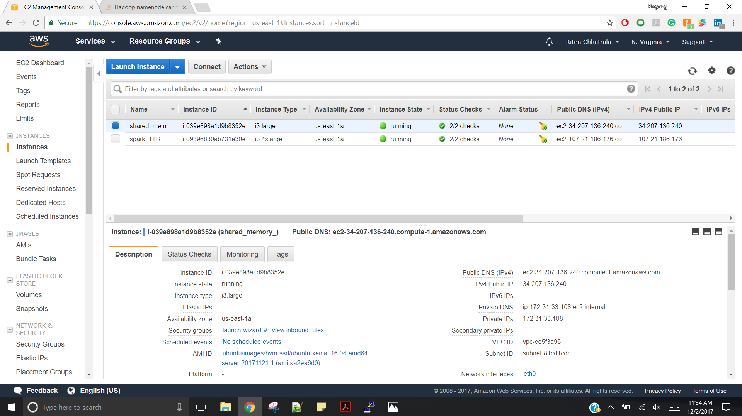

**Final Time taken by shared memory program pic:**

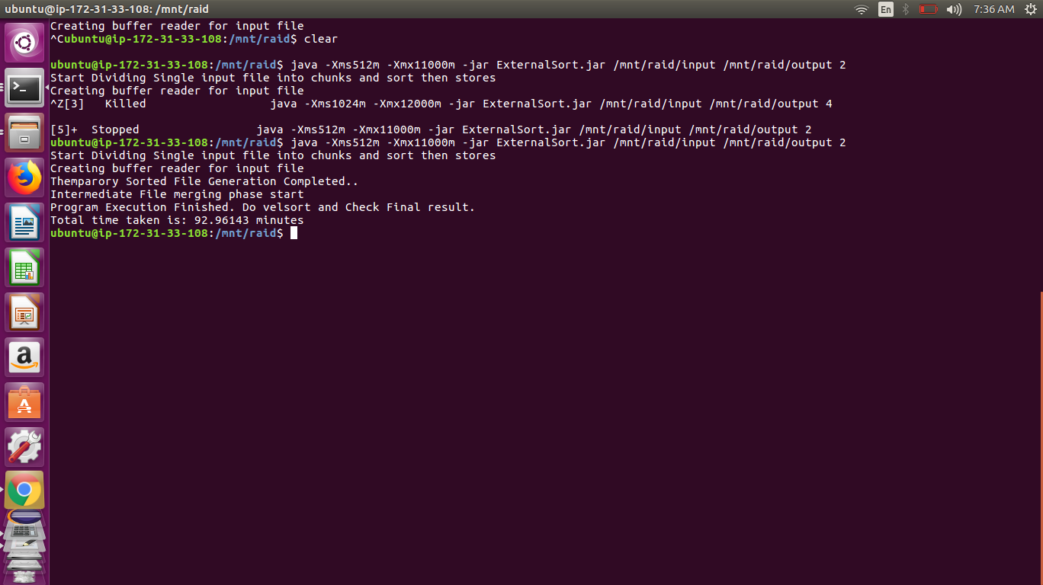

**Input and generated Output file size detail:**

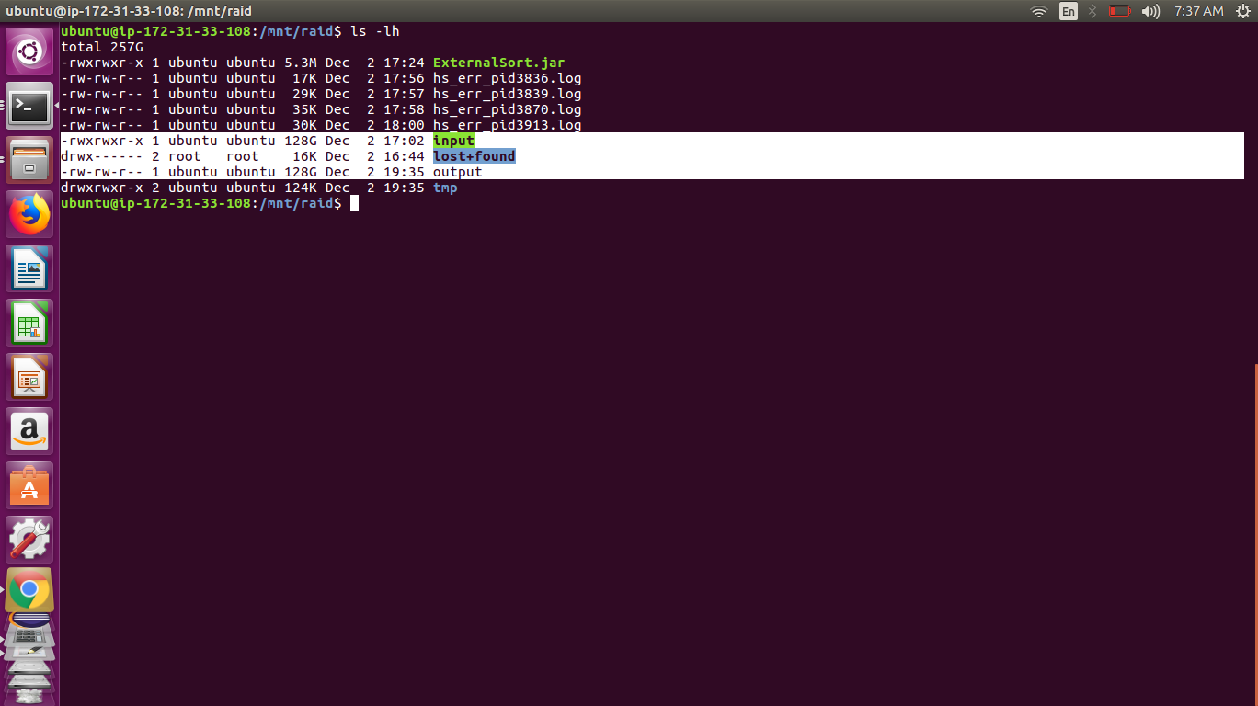

**Valsort that shows record number in output file and check sorted or not**

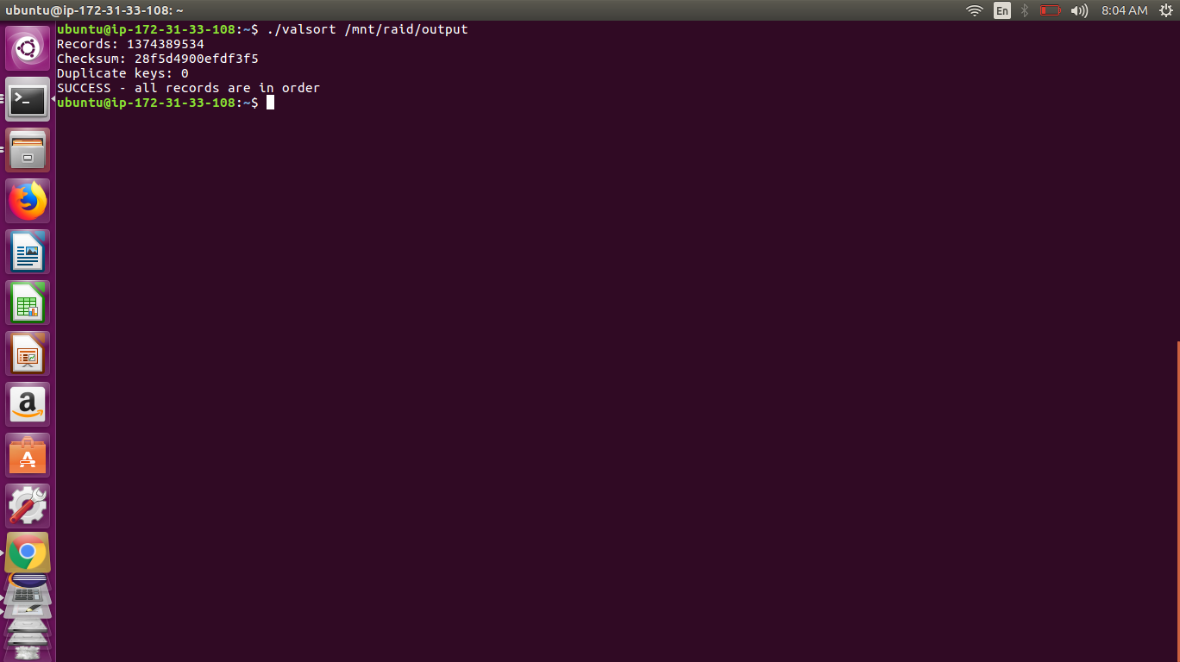

**2) 1TB Data:**

**Shows Instance name and IPs for shared memory 1TB**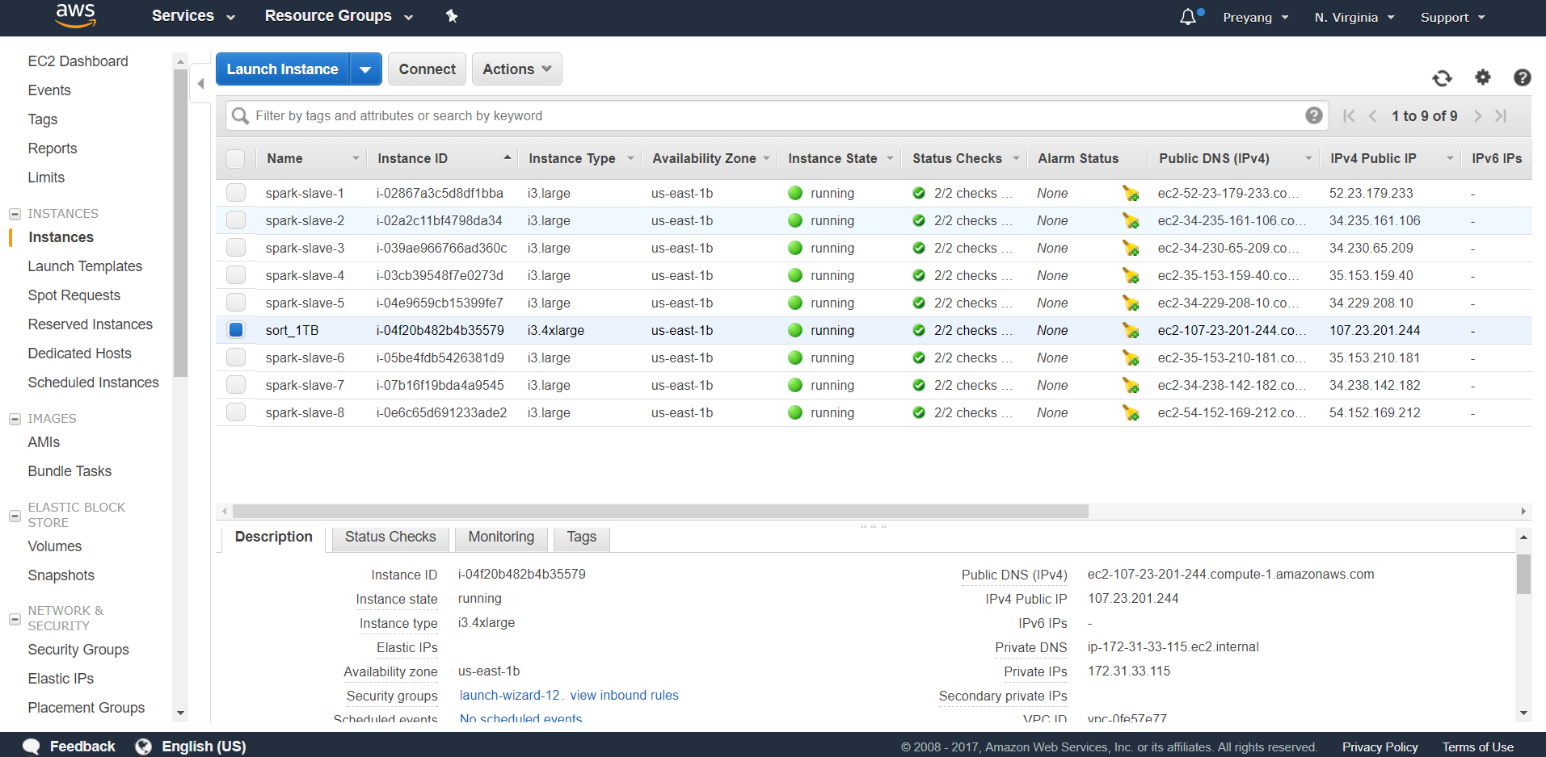

**Final Time taken by shared memory program pic:**

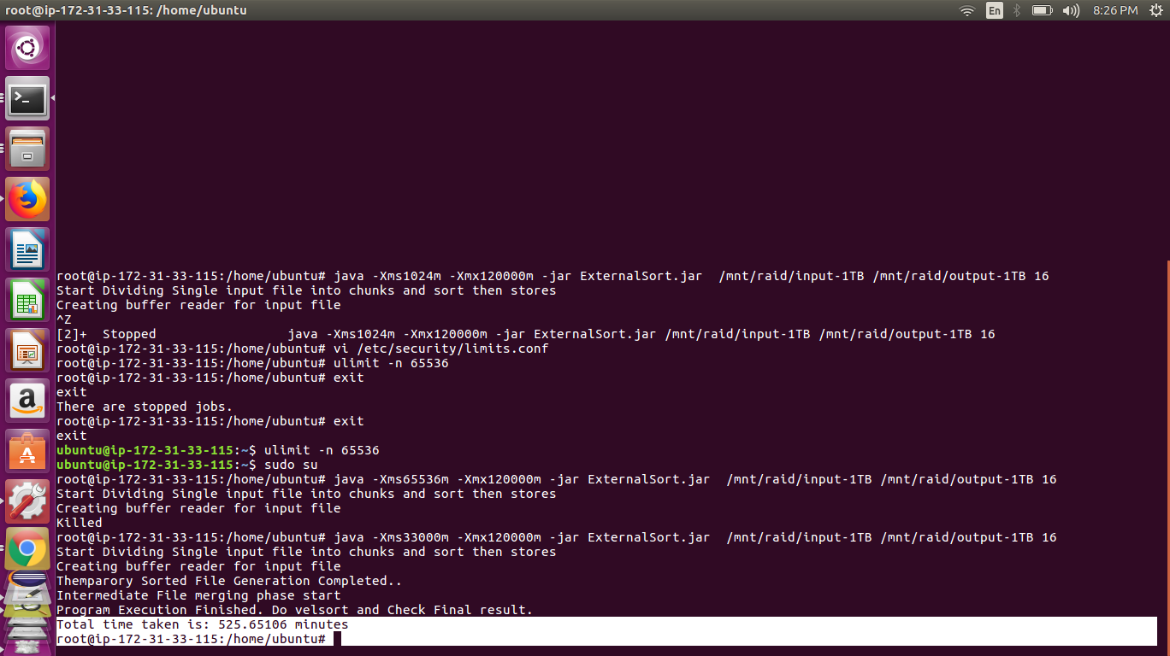

**Input and generated Output file size detail:**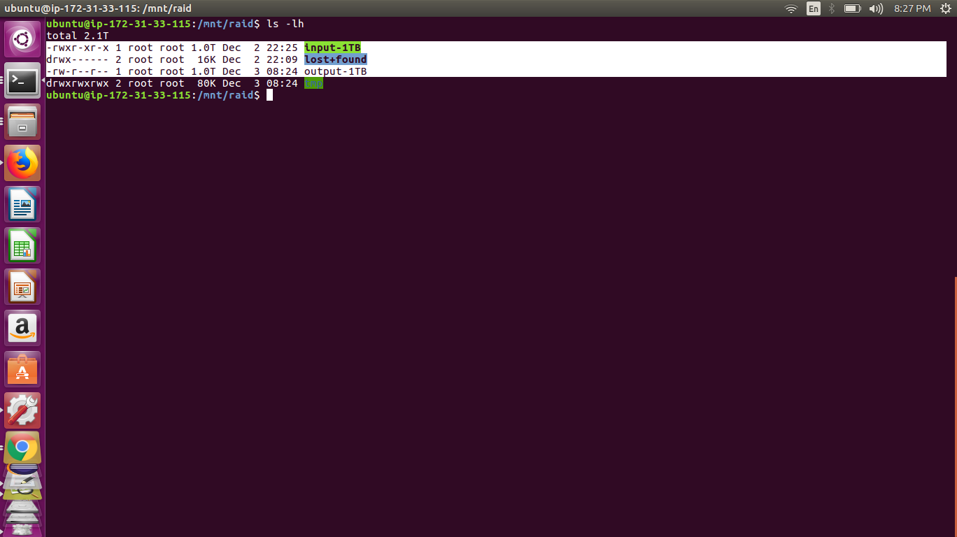

**Valsort that shows record number in output file and check sorted or not**

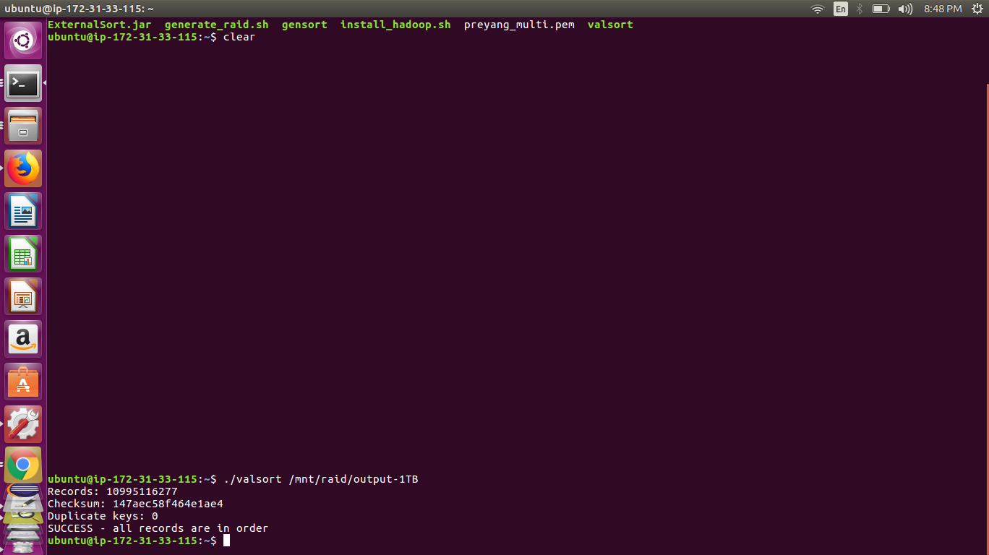

* **Hadoop single node:**

**1) 128GB Data:**

**Shows Instance name and IPs for shared memory**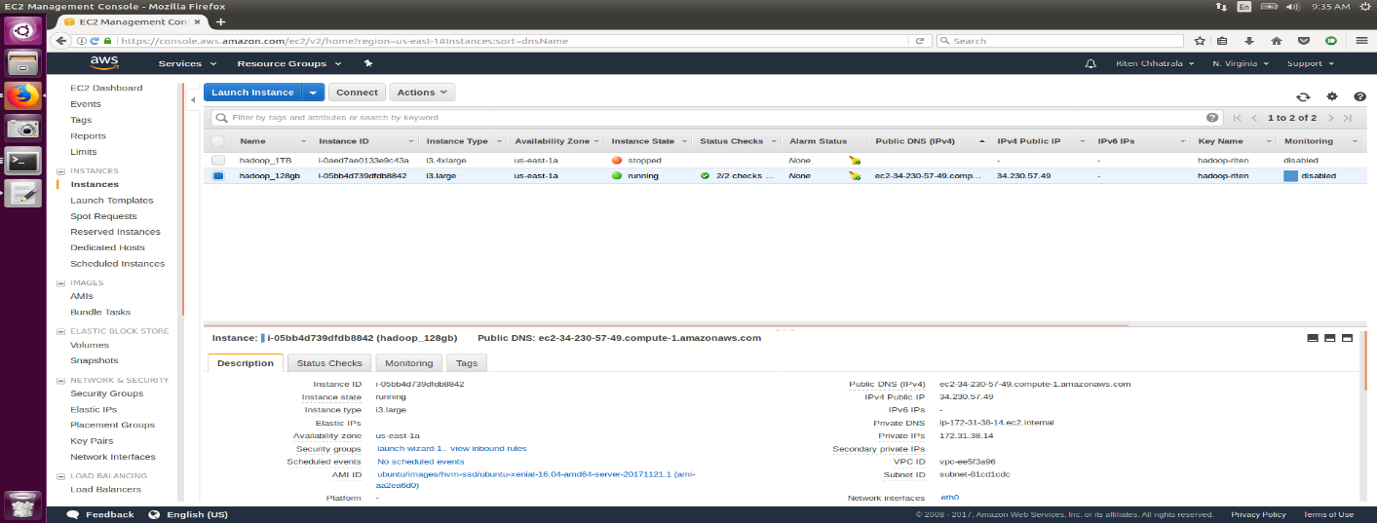

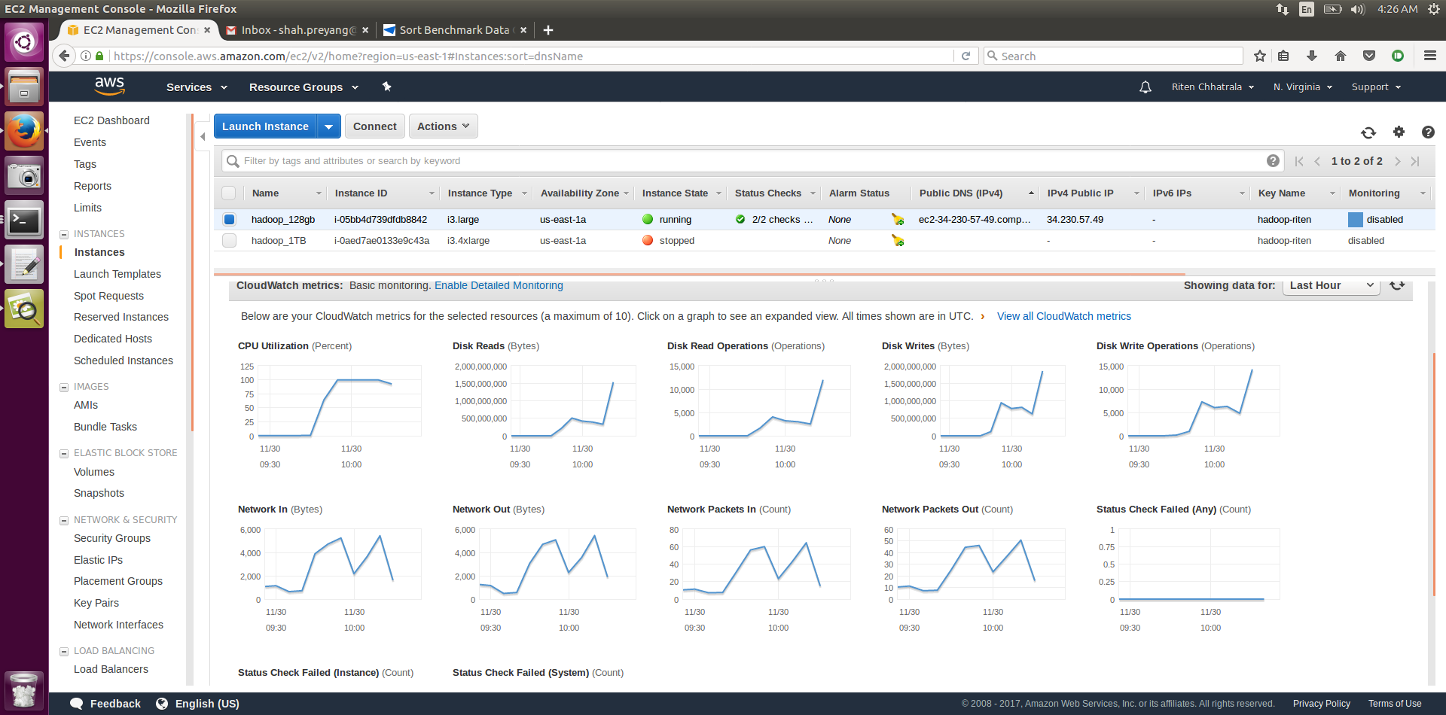

**Install_Hadoop.sh script run screenshot:**

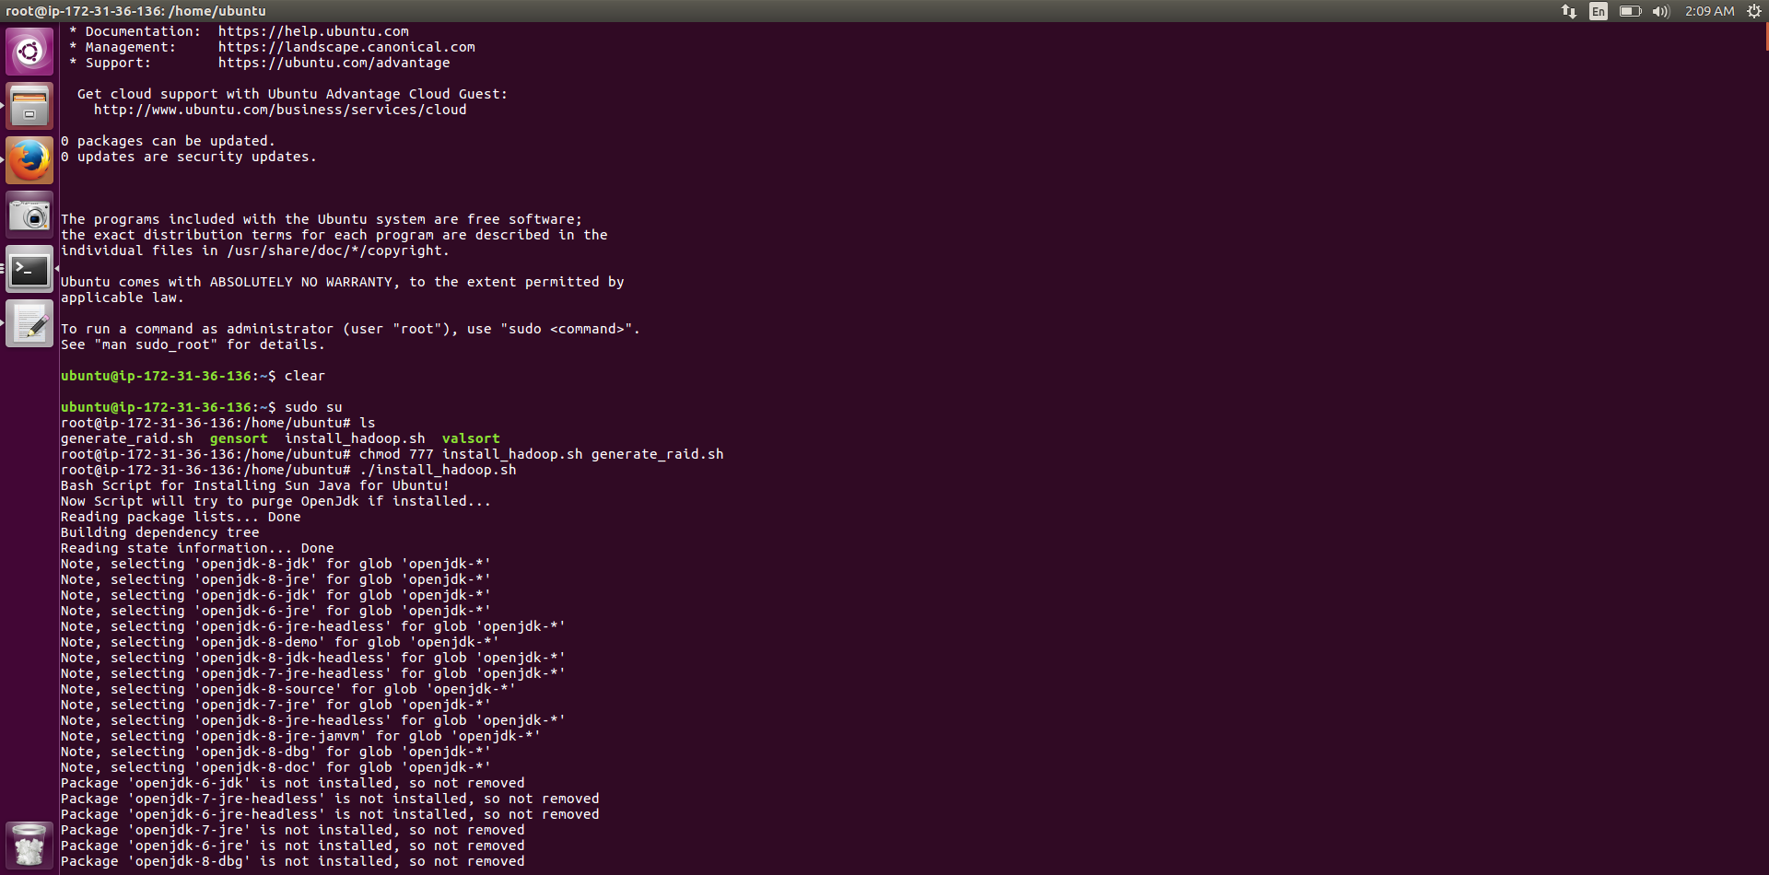

**Mount disk generate_raid.sh script to run**

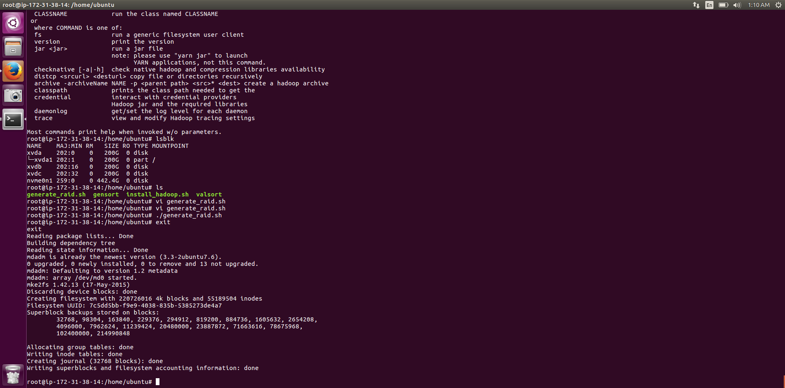

**Run gensort**

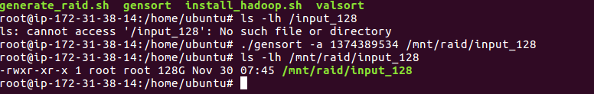

**Run Hadoop Map reduce Programe**

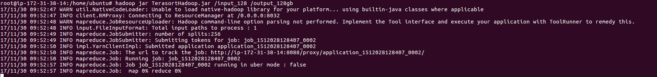

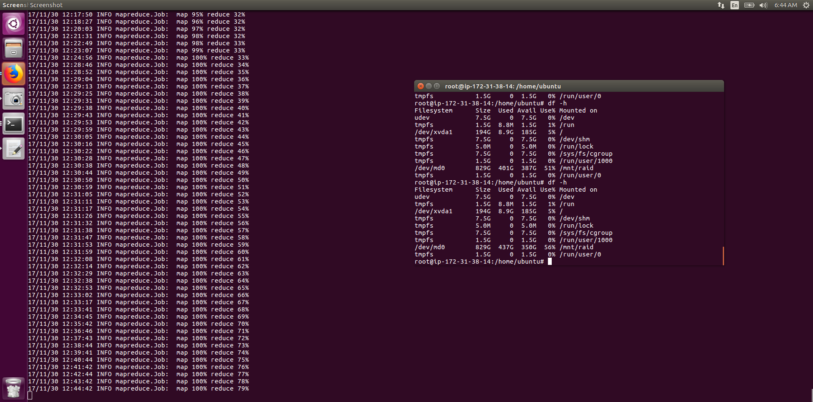

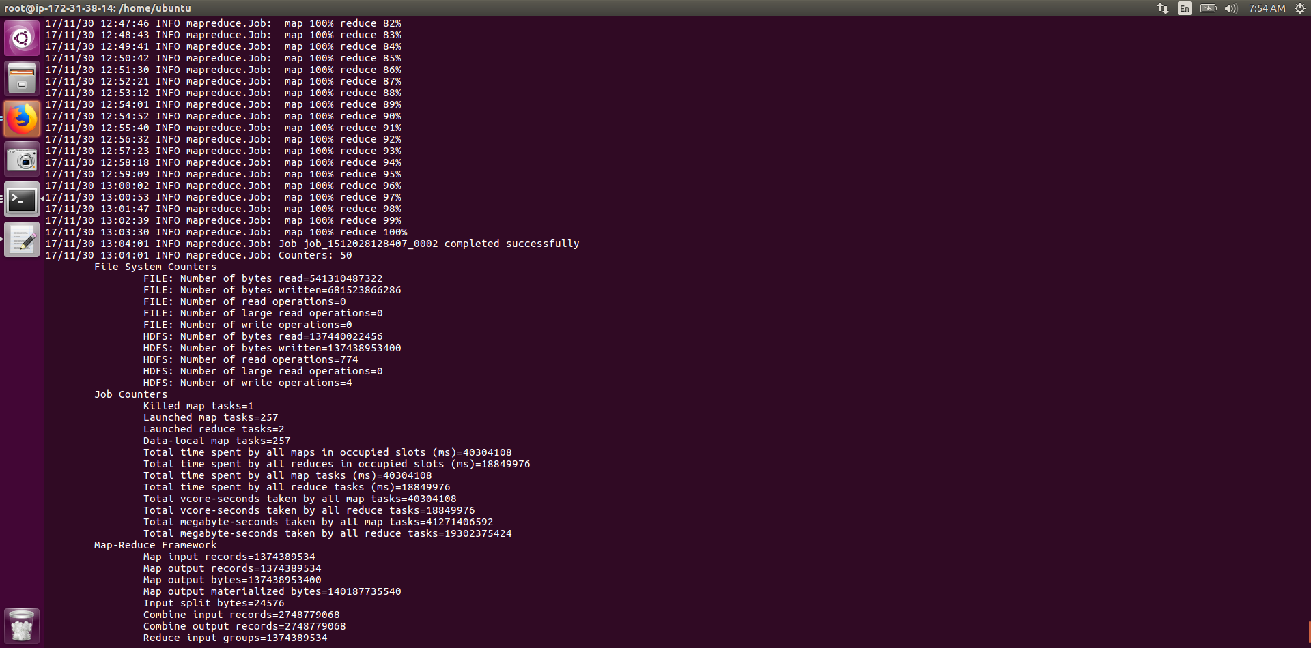

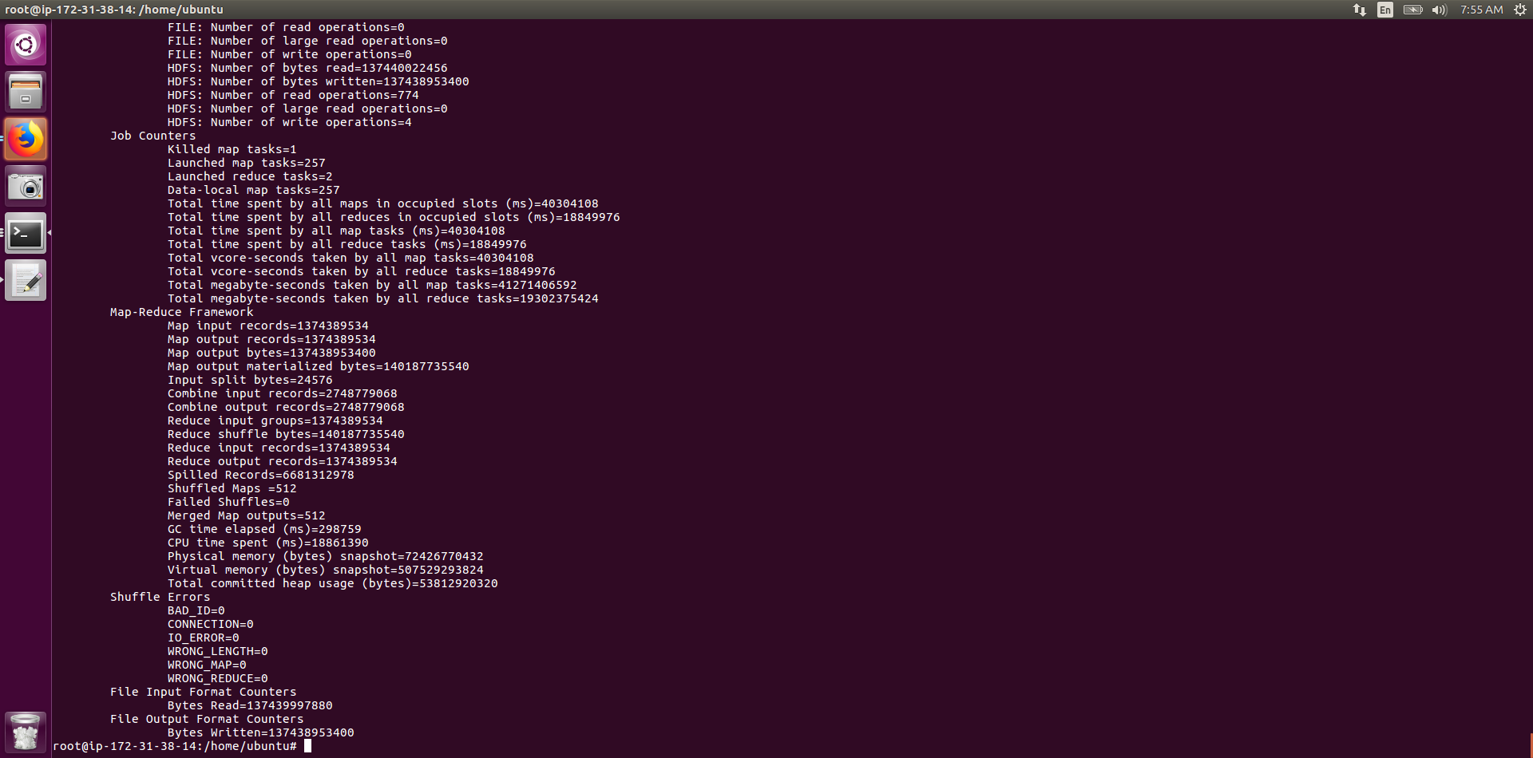

**Output Files details**

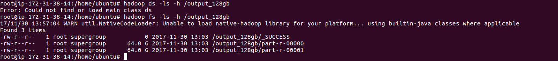

**Valsort of both files**

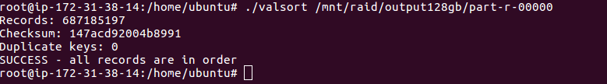

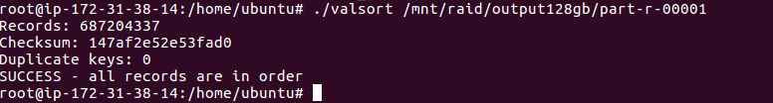

**2) 1TB Data:**

**Instance Detail**

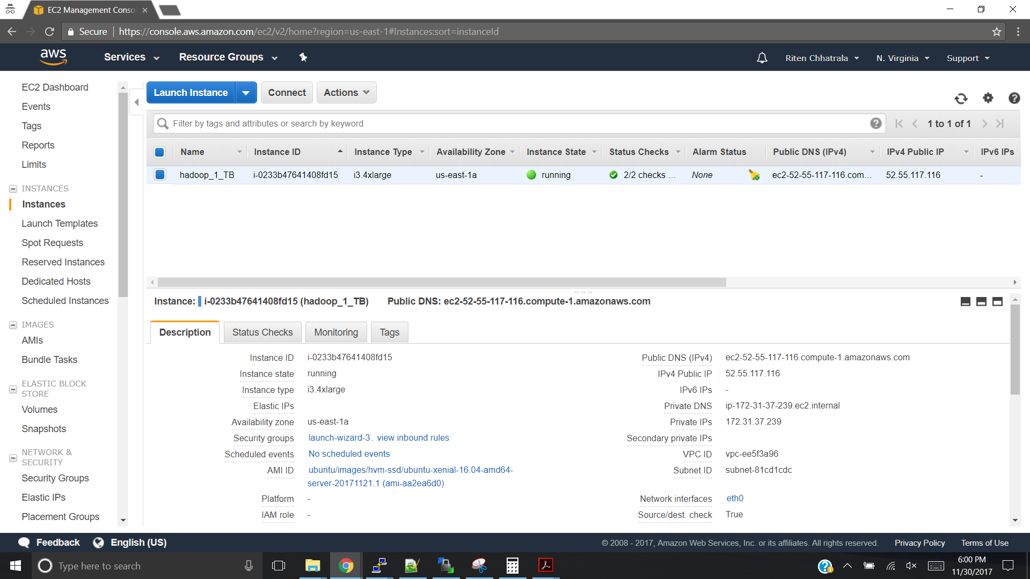

**Mounted Disk after running generate_raid.sh**

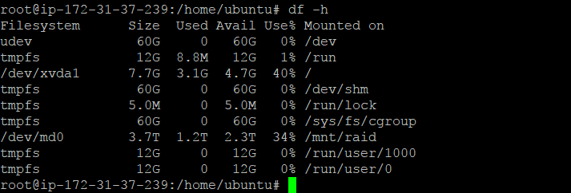

**Run Hadoop Map Reduce java Jar program**

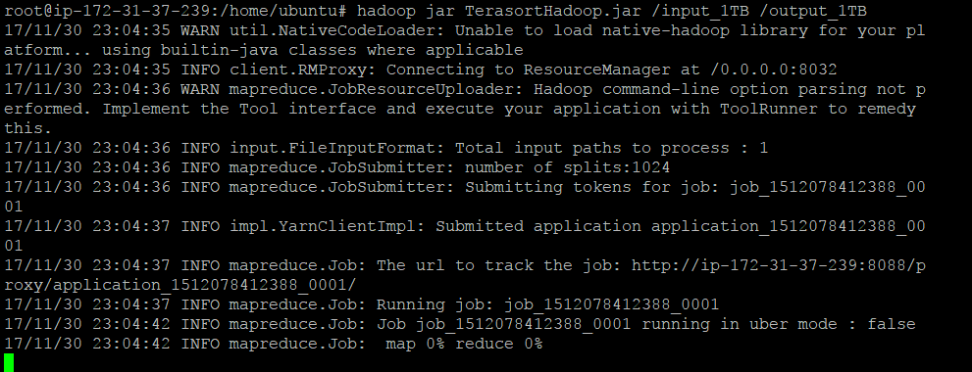

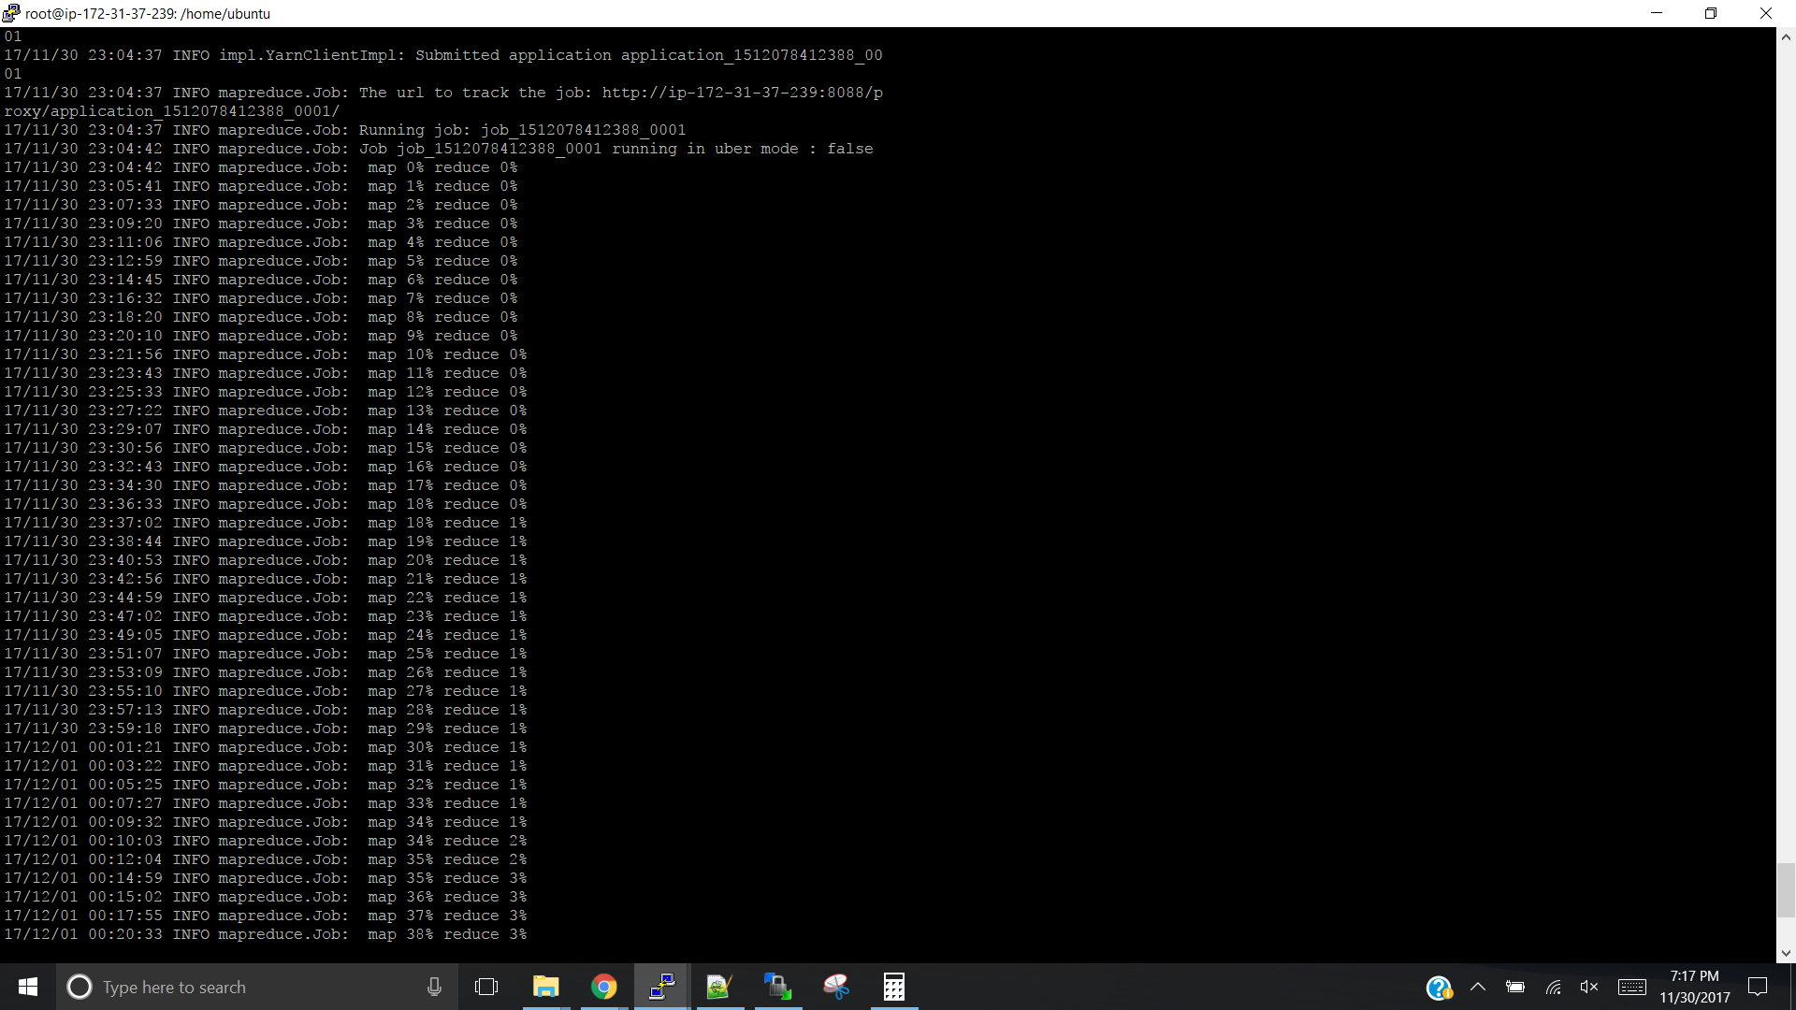

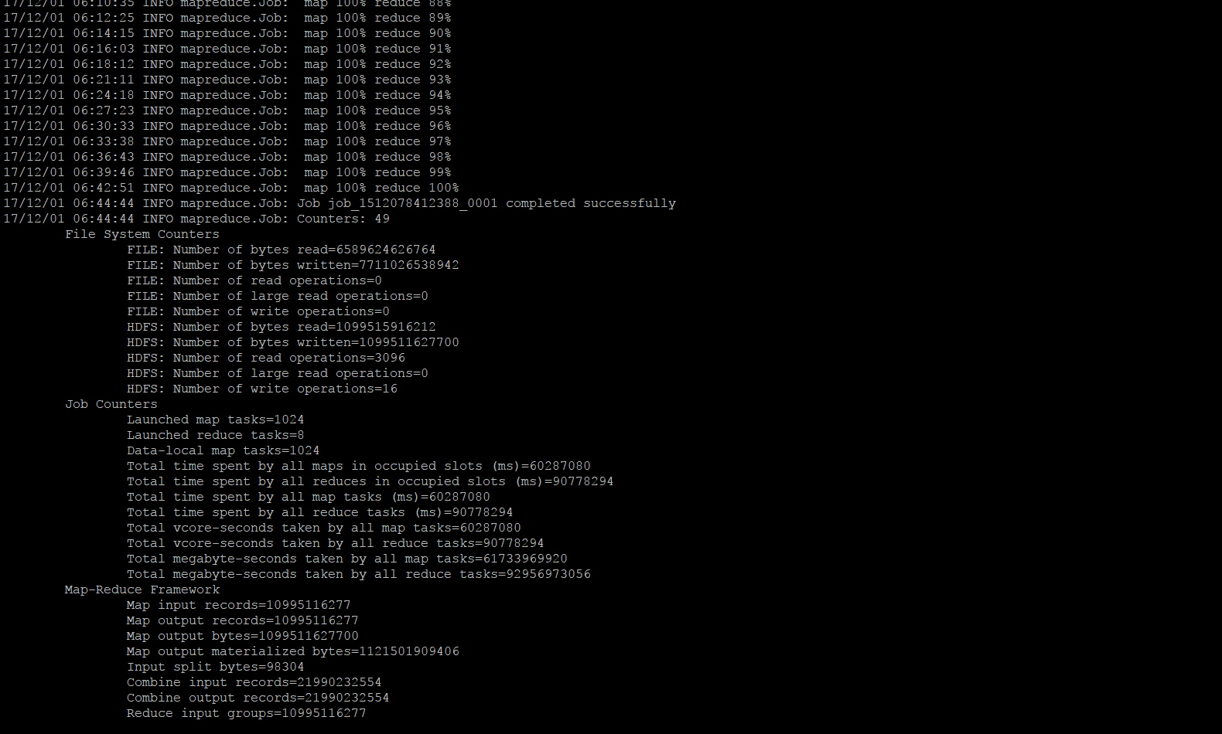

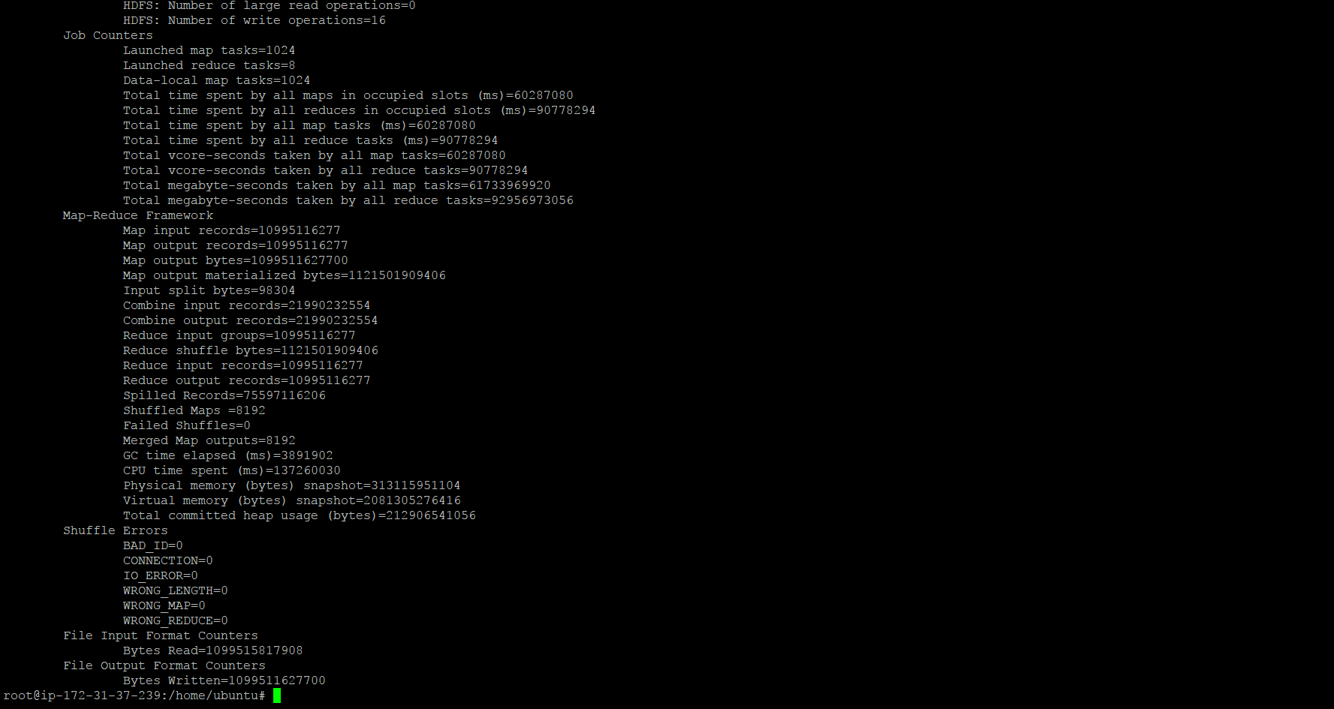

**Output Files for 8 reducer**

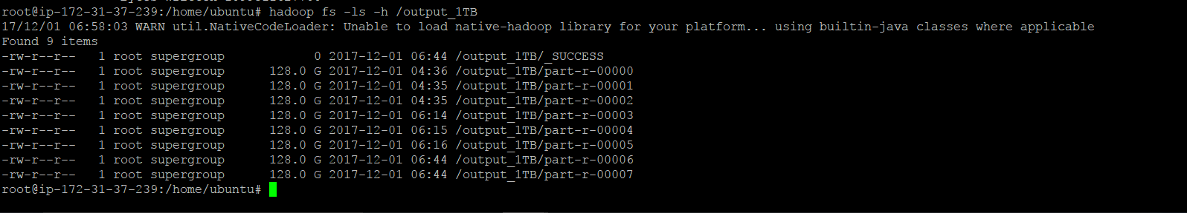

**Valsort of all files:**

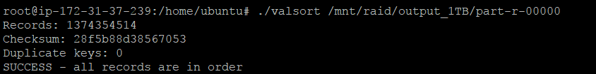

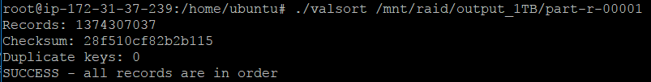

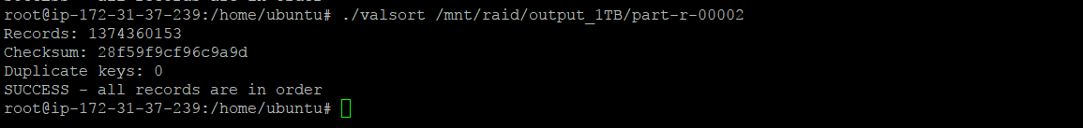

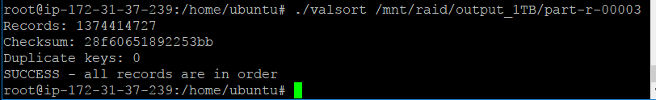

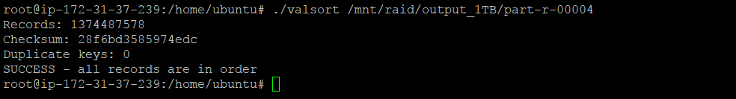



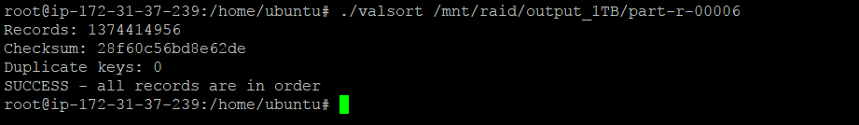

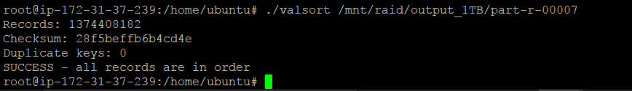

**3) Hadoop multi-node:**

**All-Instance Details and Ips:**

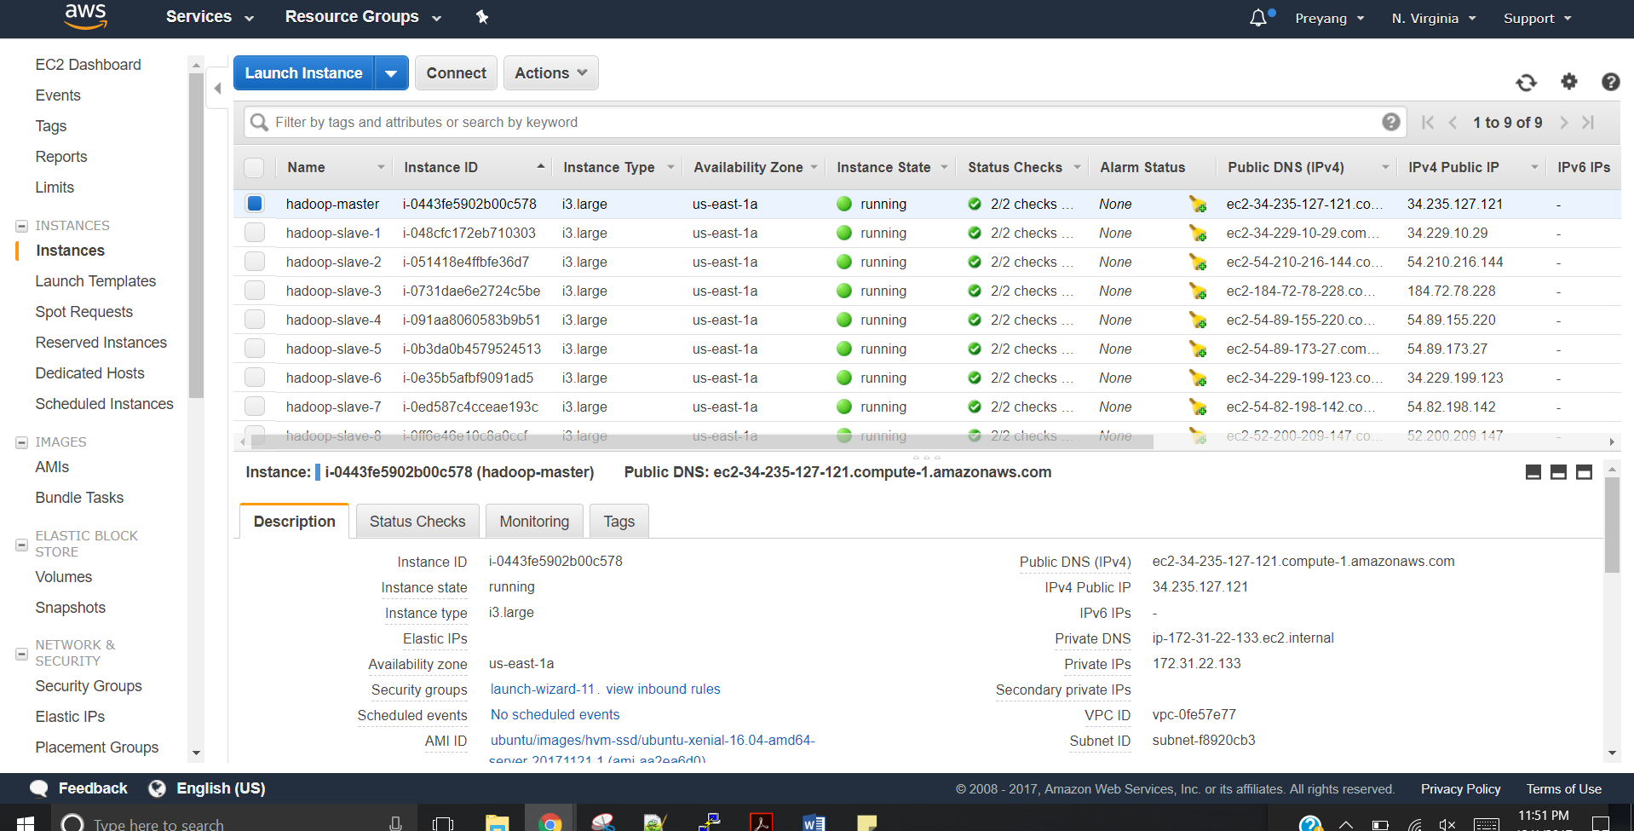

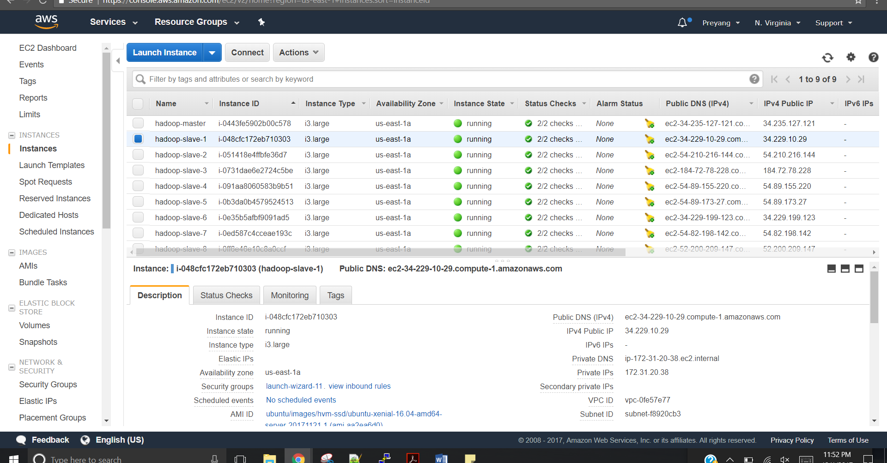

**Apache browser: Shows cluster with running slave nodes**

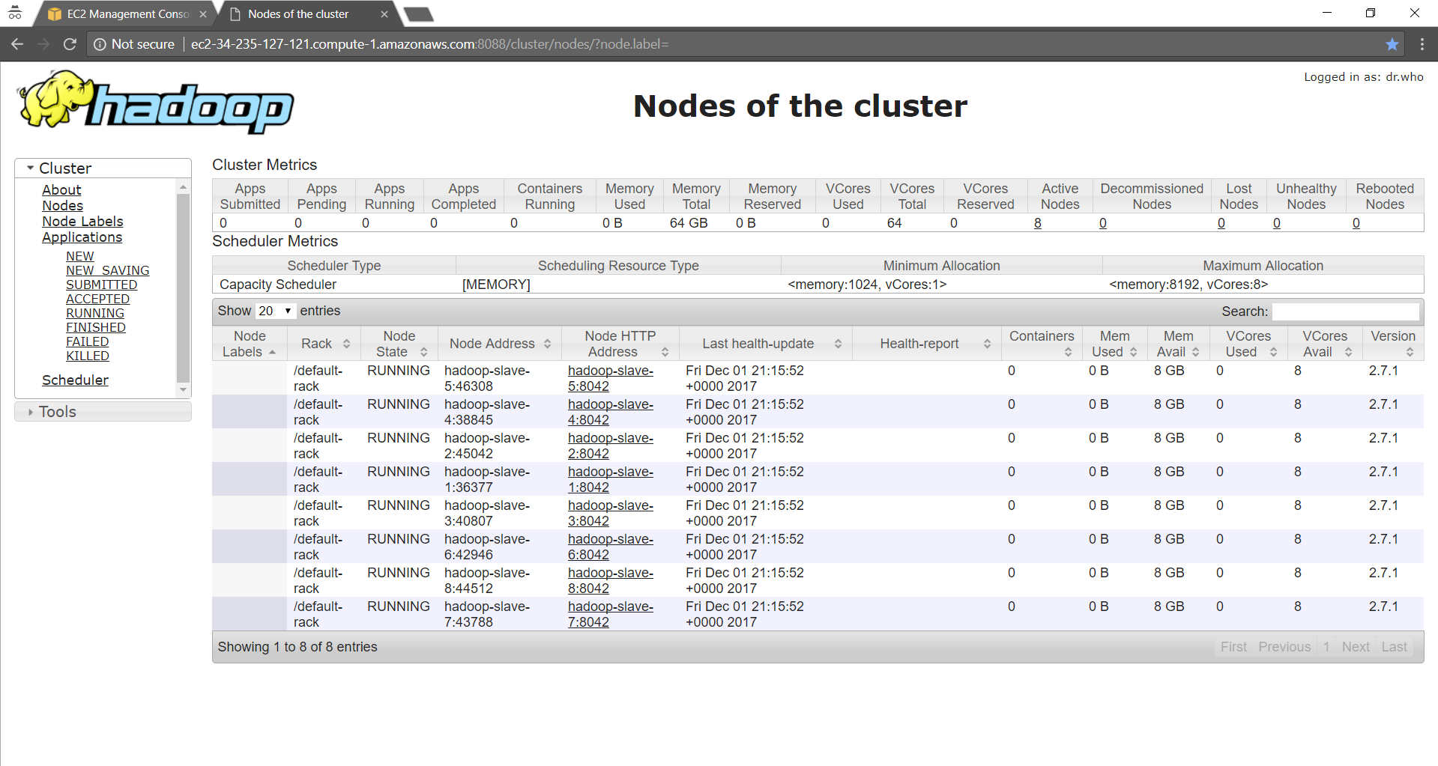

**Generate_raid and put in hdfs**

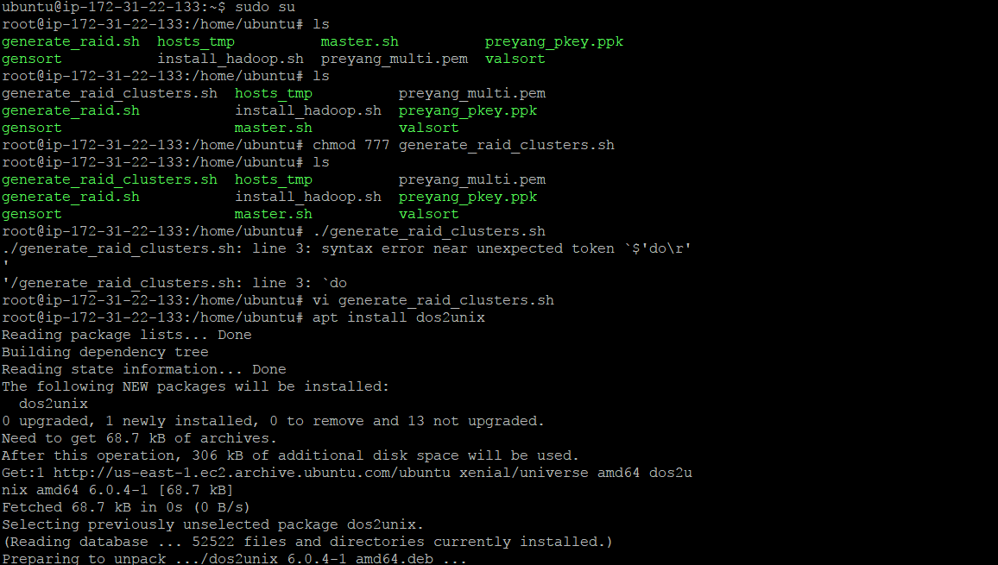

**Running Hadoop Program on 8 node Cluster**

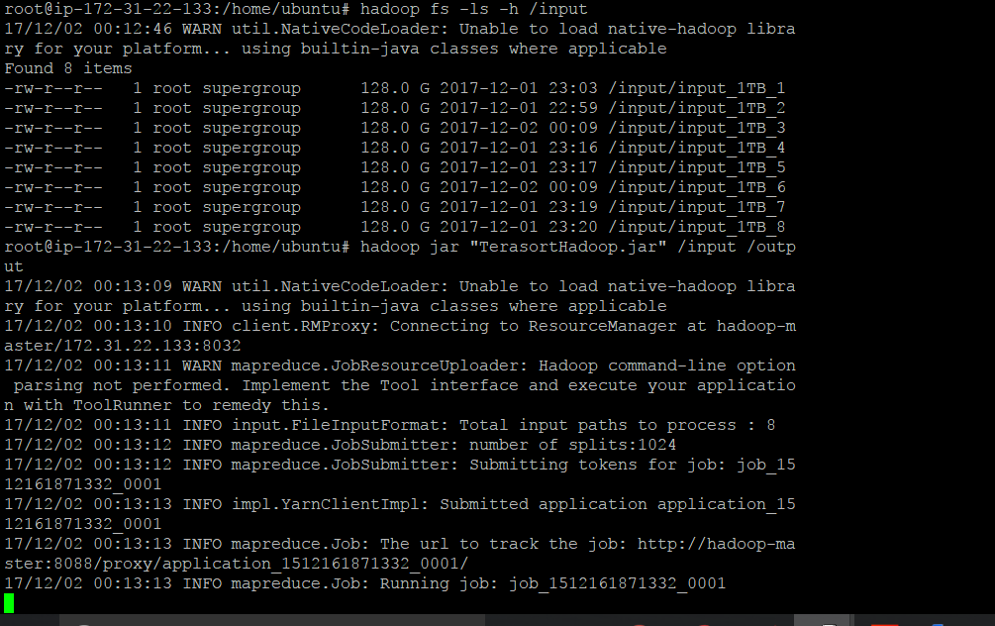

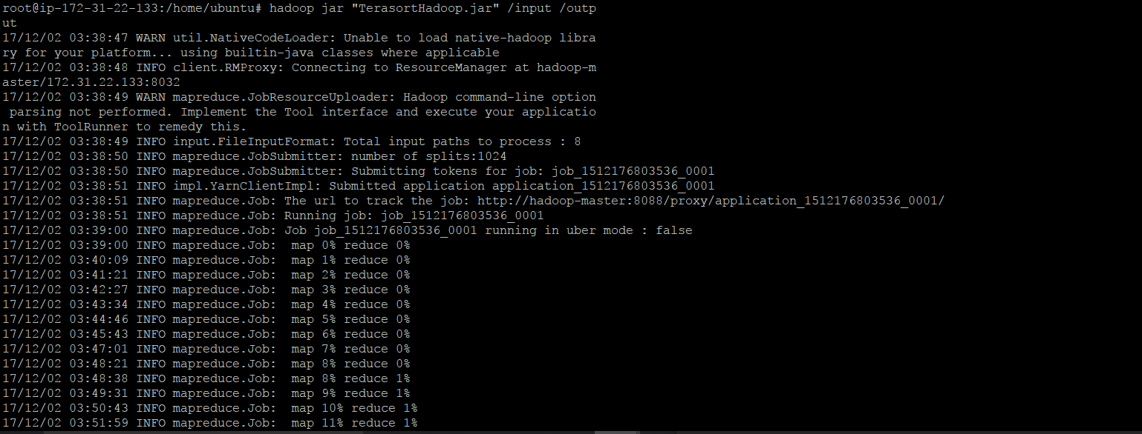

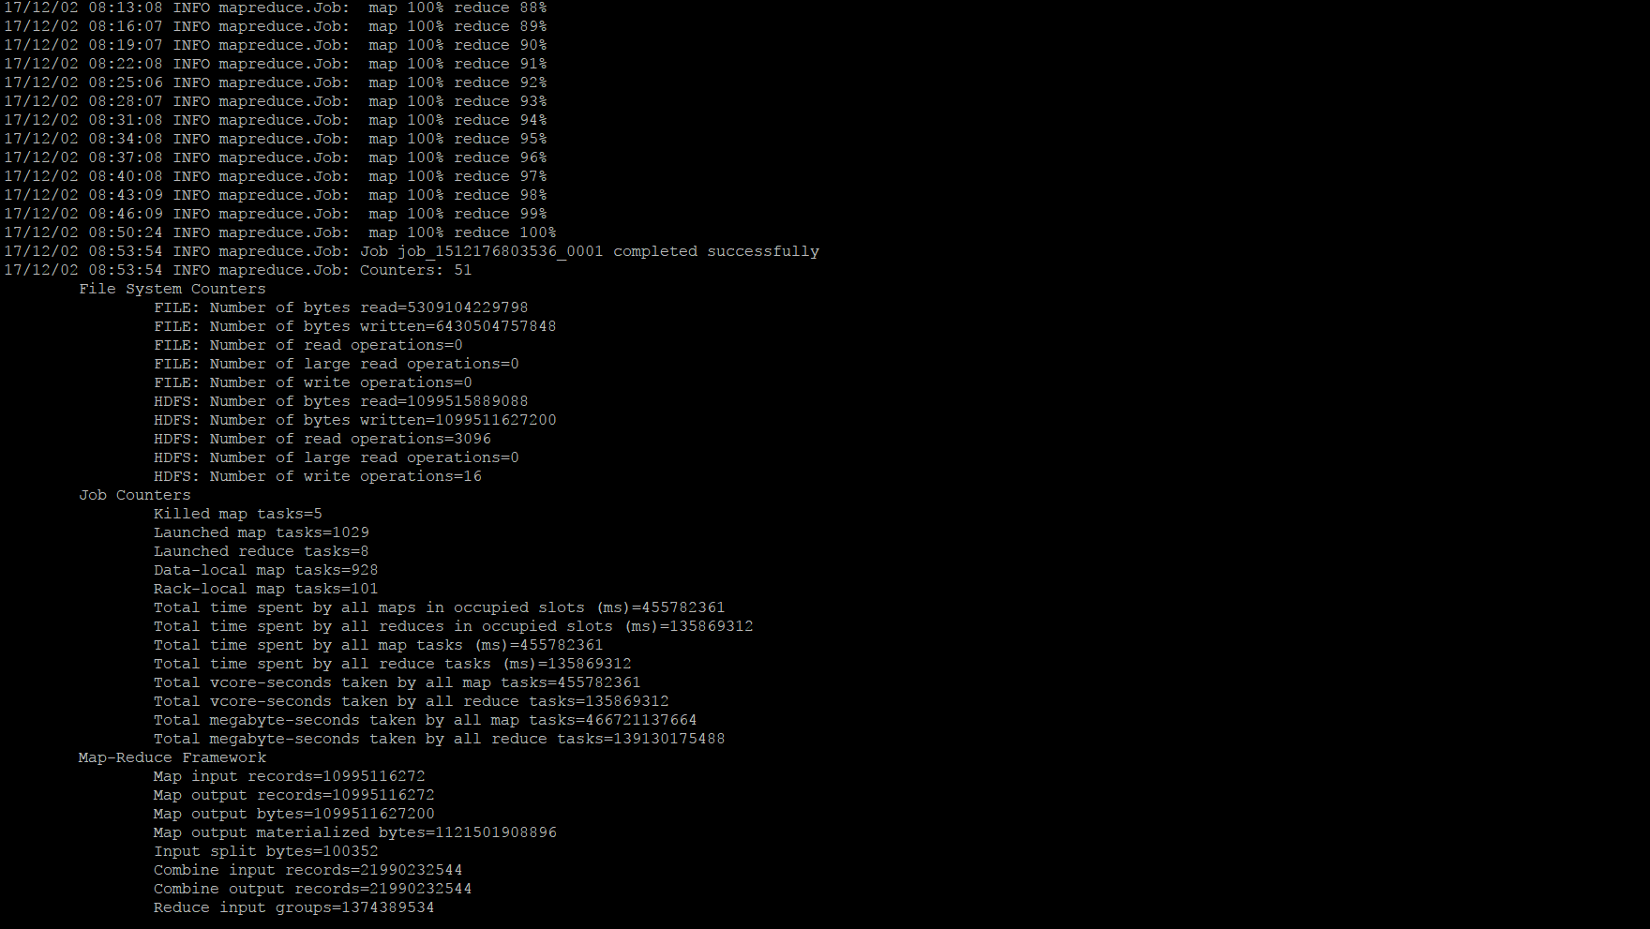

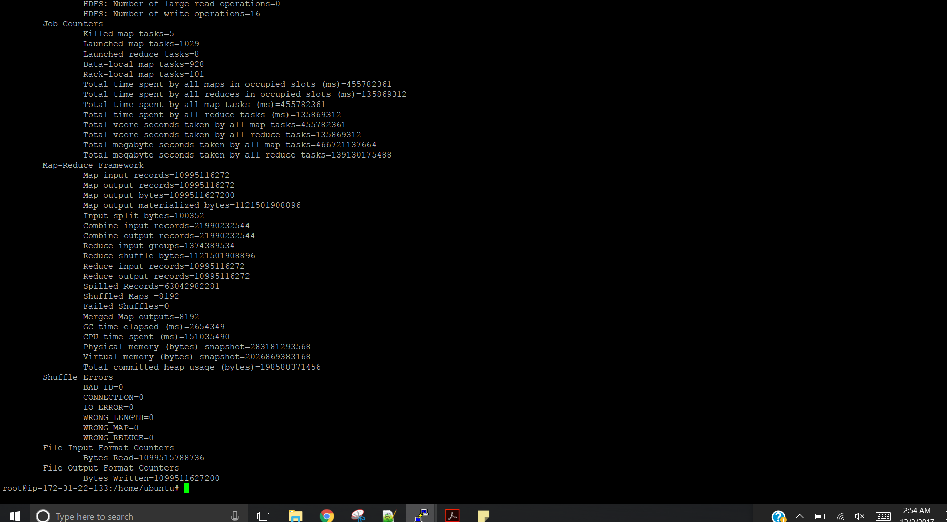

**After running the job**

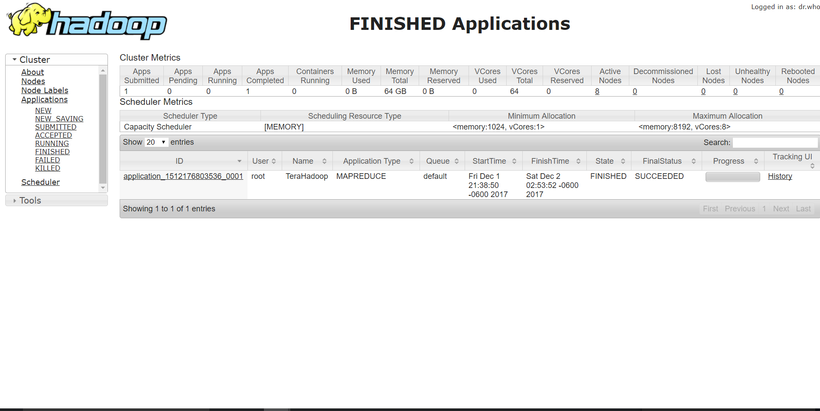

**Output files**

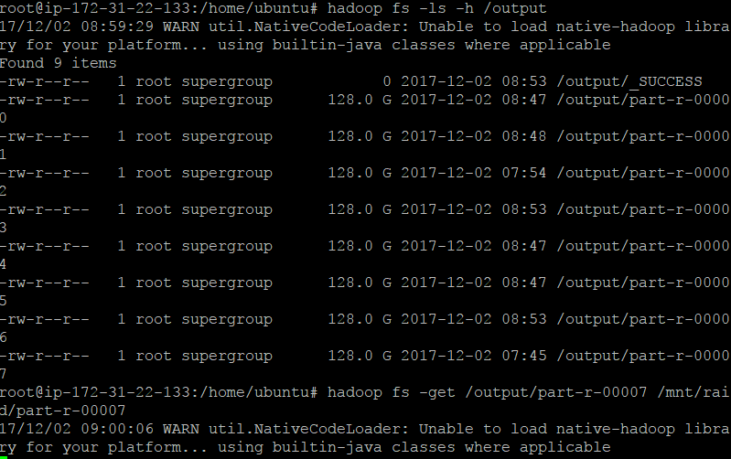

**Valsort of first and last file**

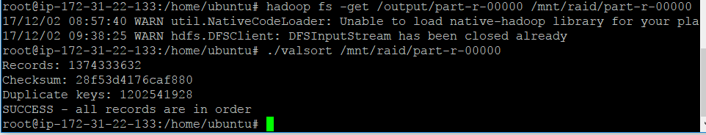

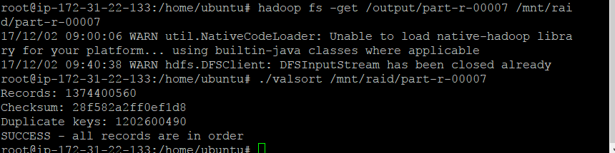

* **Spark single node:**

**1) 128 GB**

**Instance Detail**

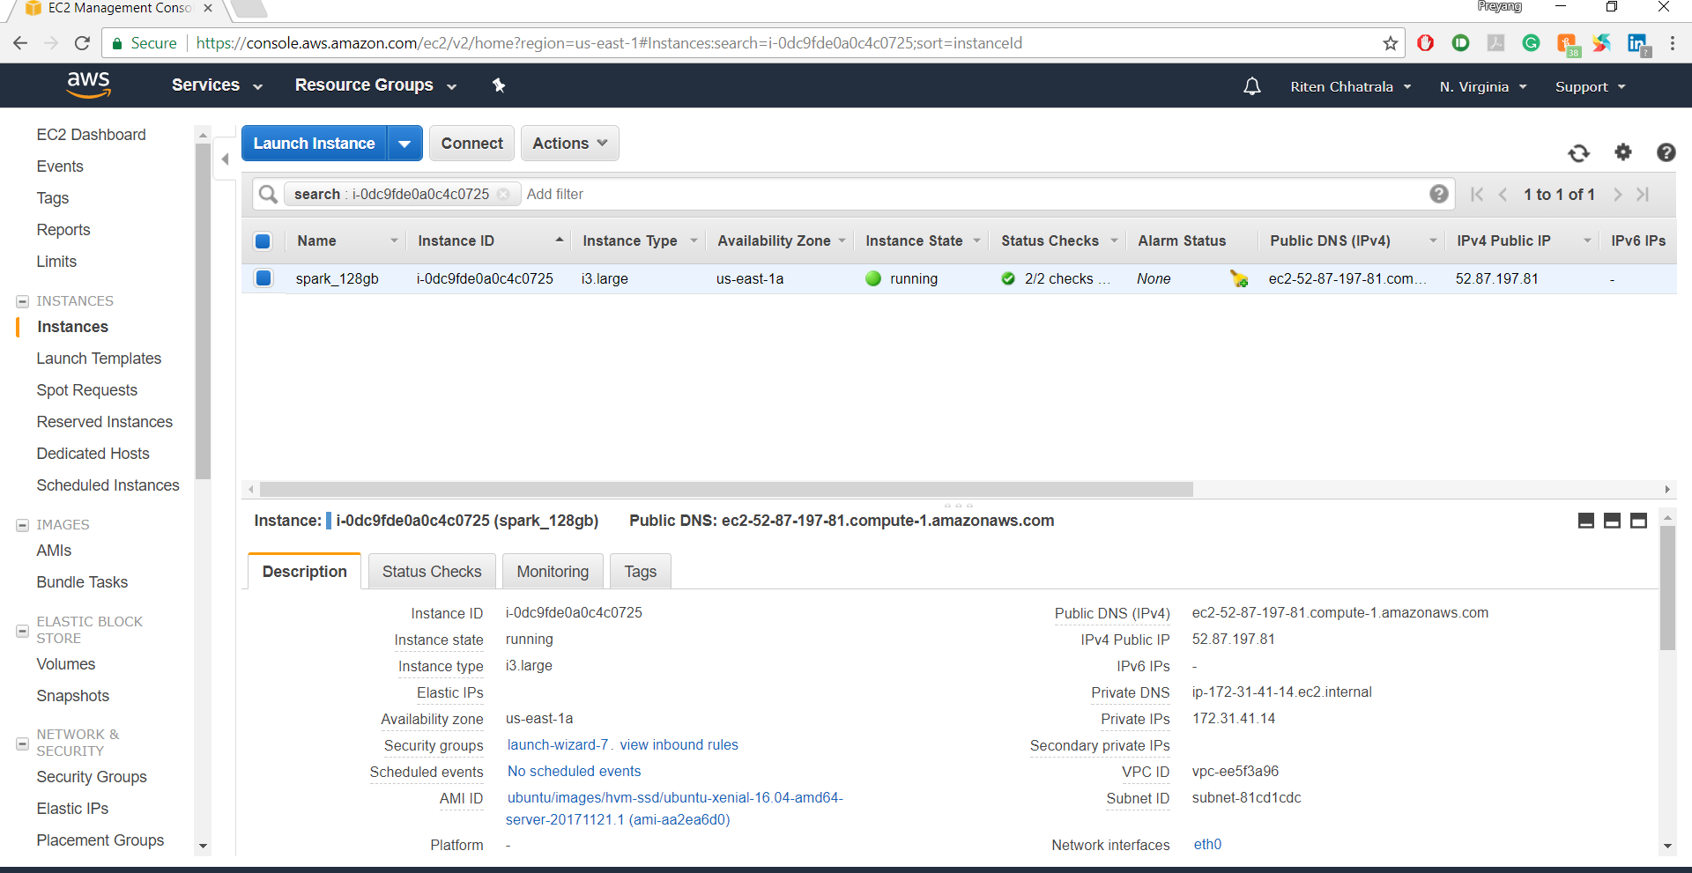

**Mount disk and gensort**

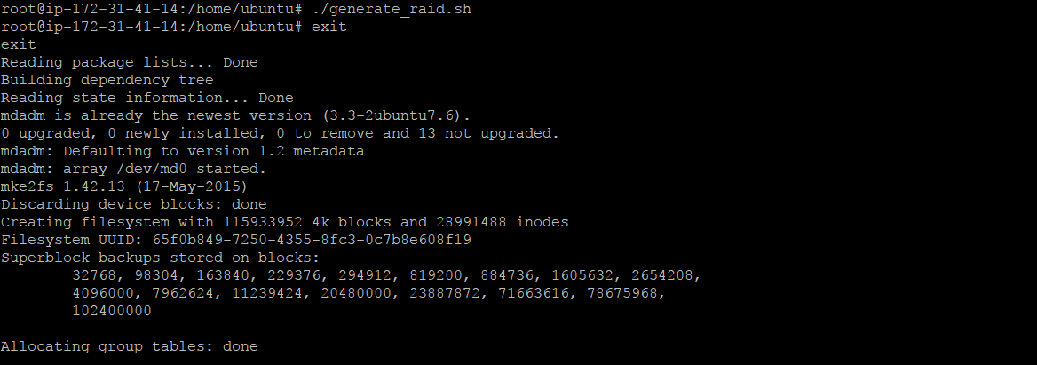

**Run spark script**

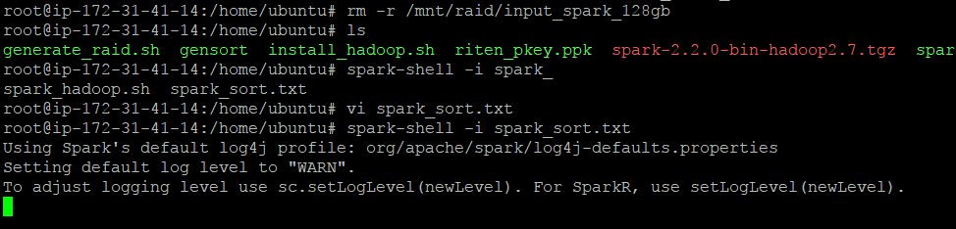

**Result time in nano seconds**

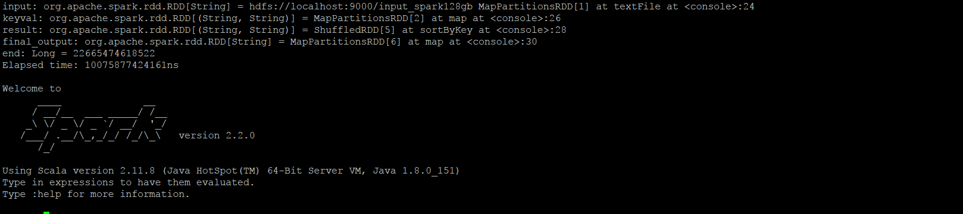

**OutputFiles**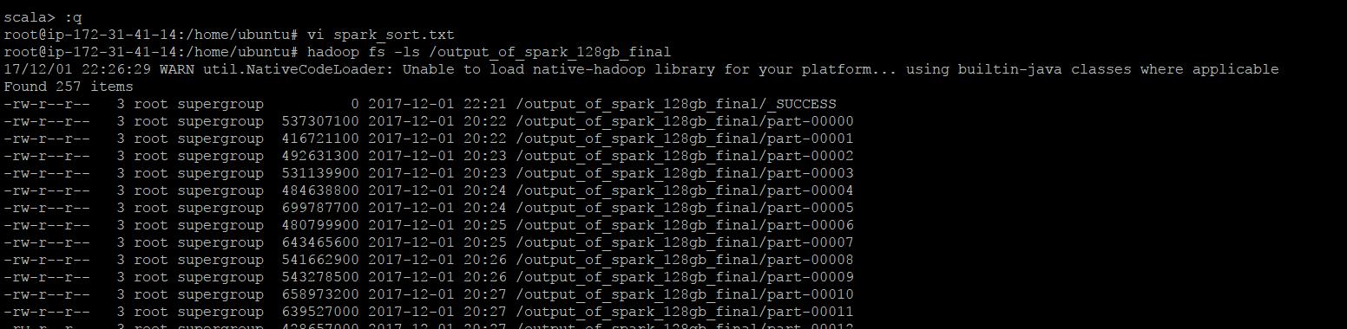

**Valsort of some files**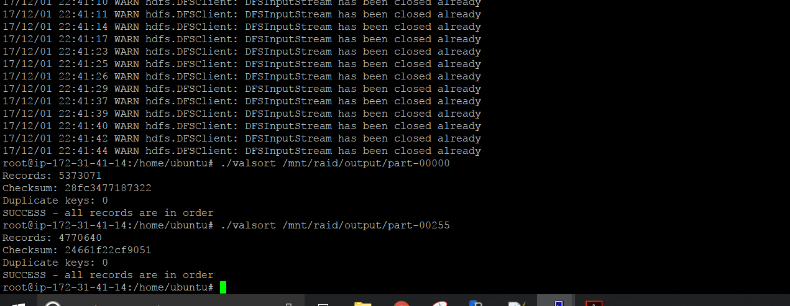

**2) Spark for 1TB:**

**Instance Details**

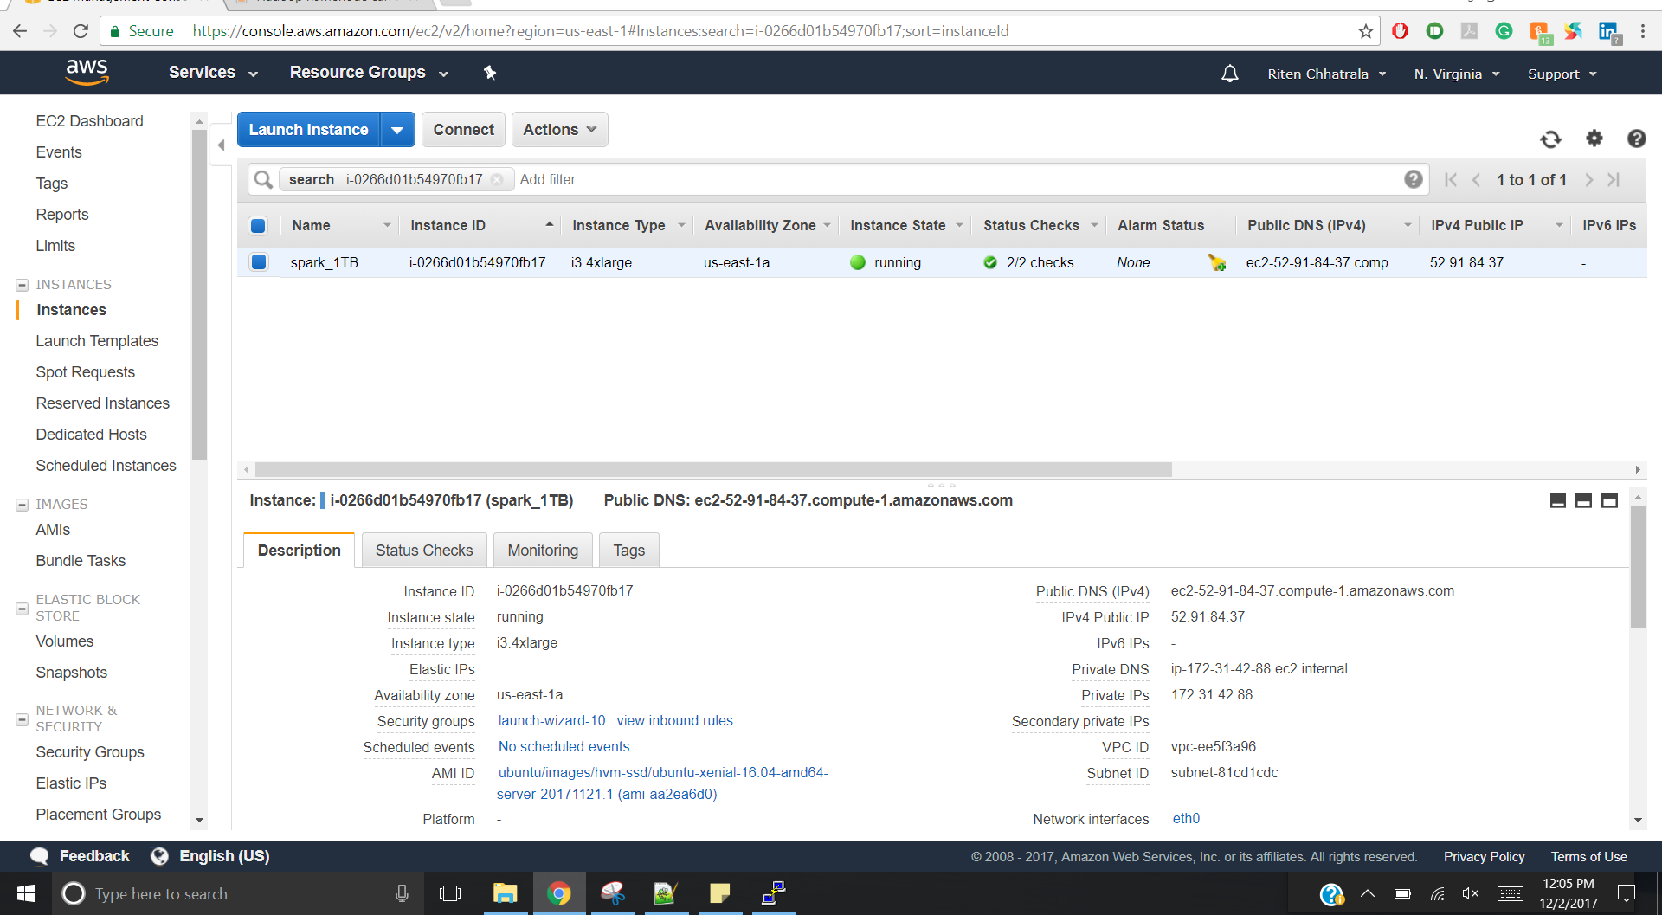

**Running spark script**

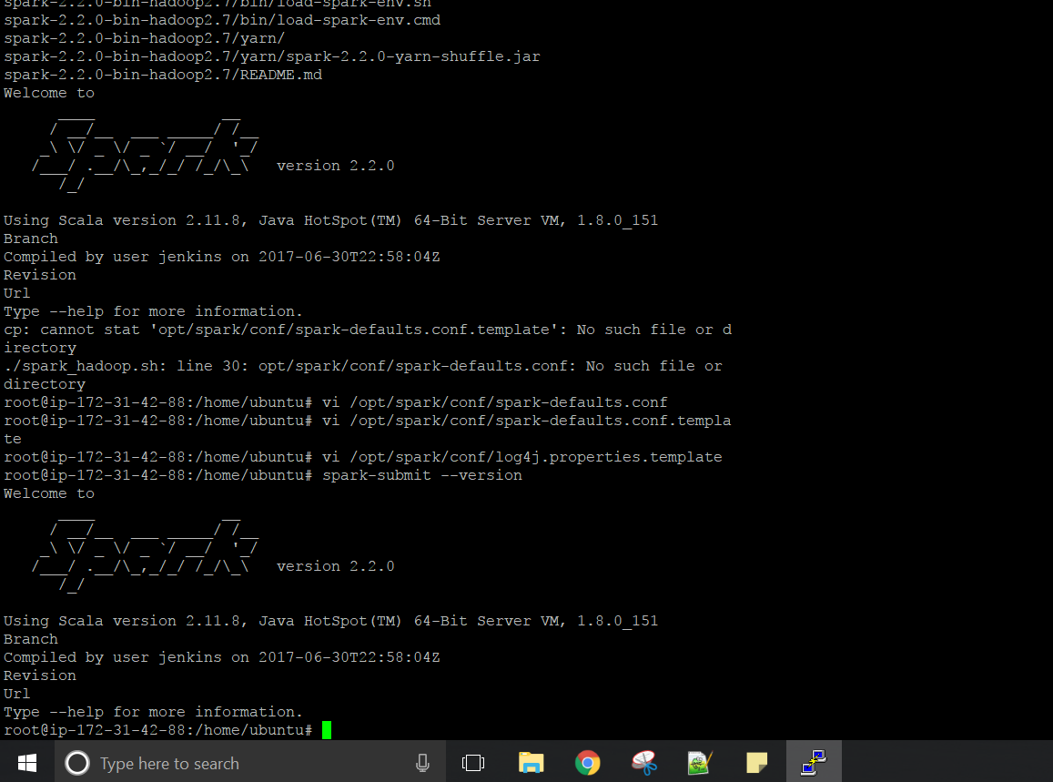

**Mount disk and gensort**



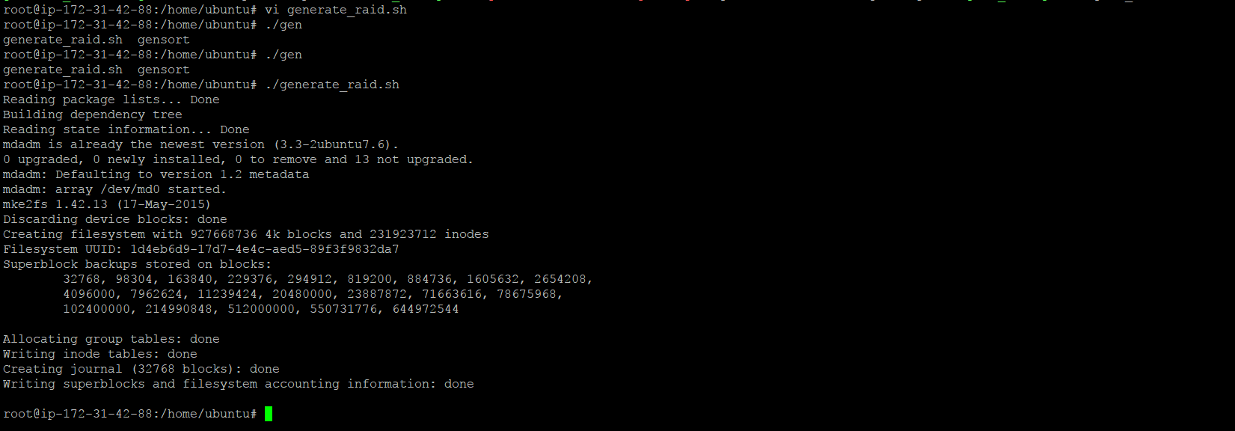

**Running of Spark script in stages:**

**Stage-0 spark run**

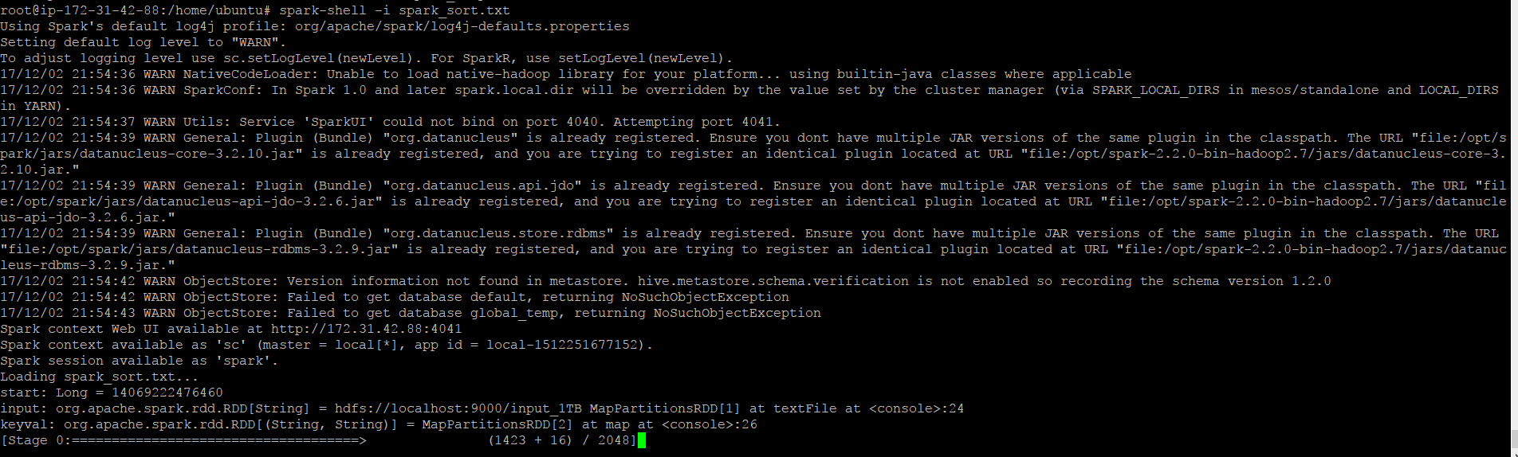

**Stage1 spark run**

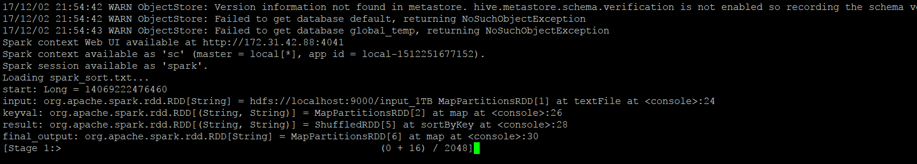

**Stage- 2 spark run**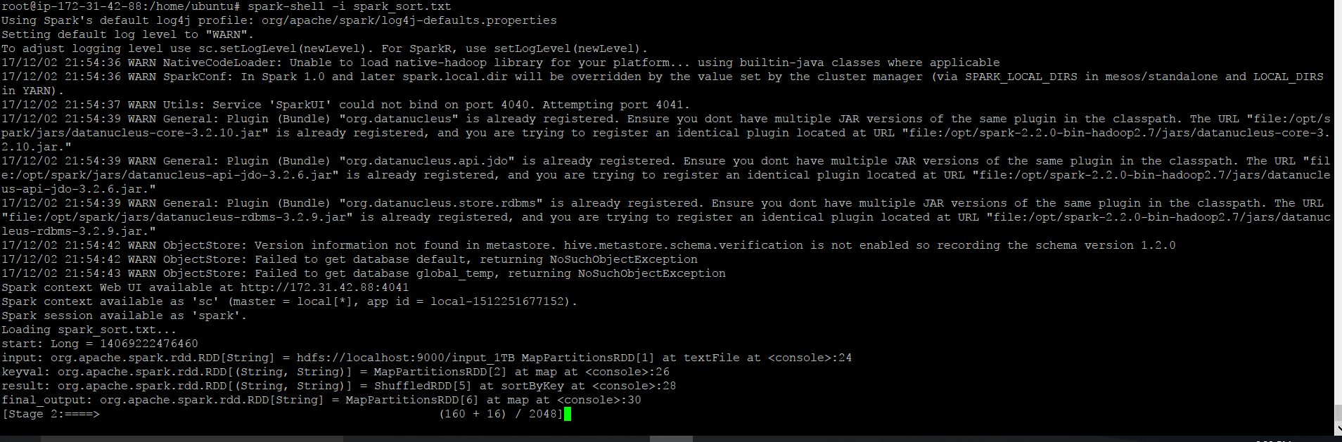

**Shows final time required to run spark script in ns**

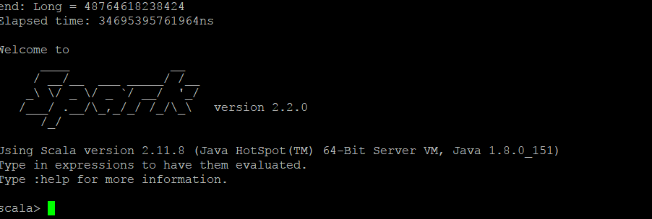

**Output files**

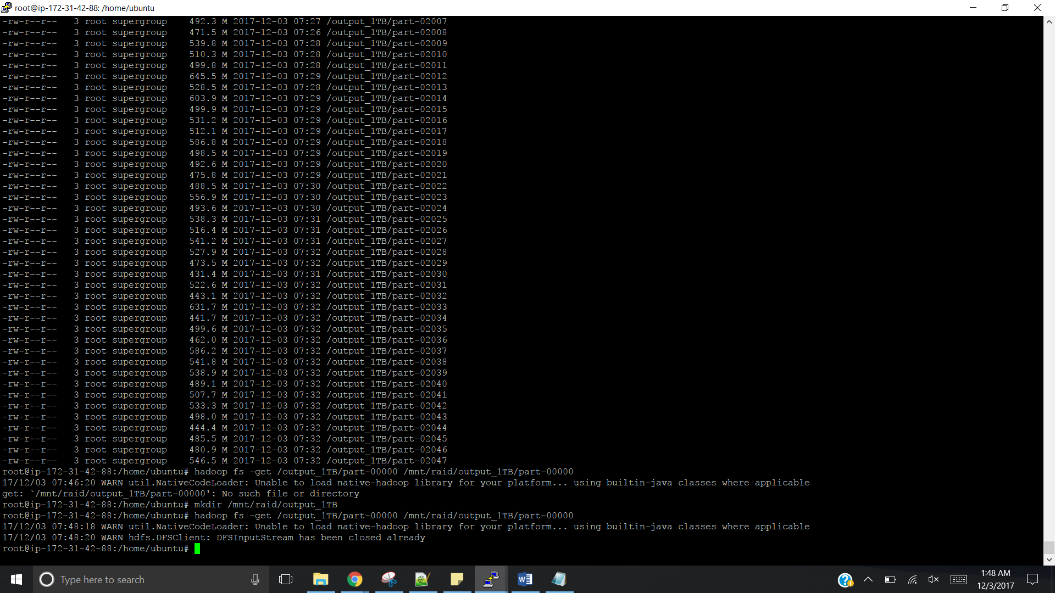

**Valsort on some file**

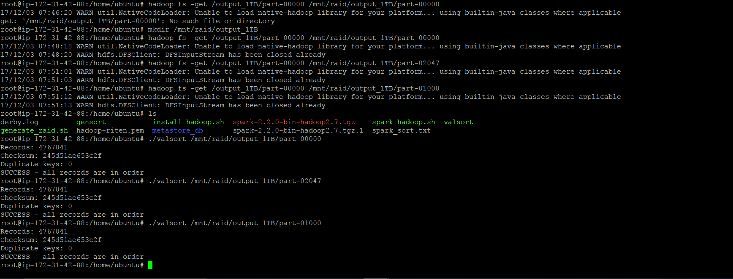

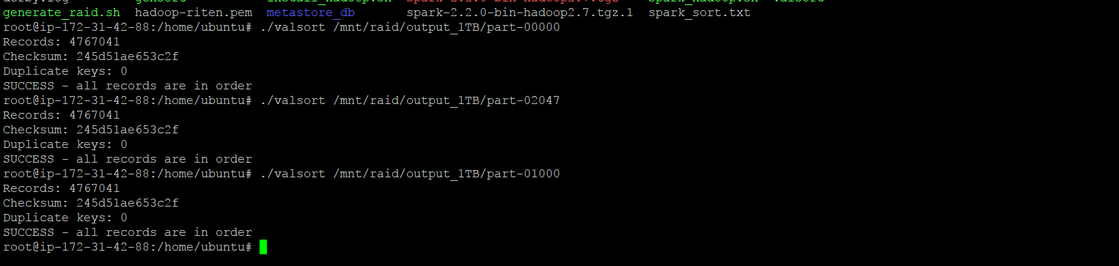

* **Spark multi-node:**

1. **10GB:**

Final Result of spark script run

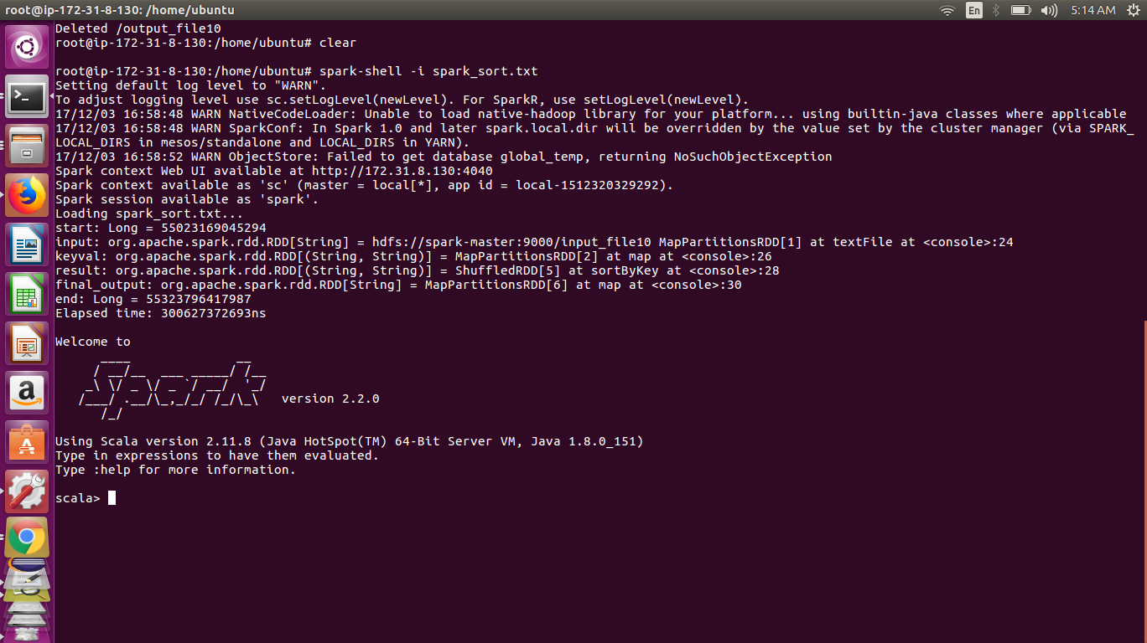

Running Spark Stages in browser

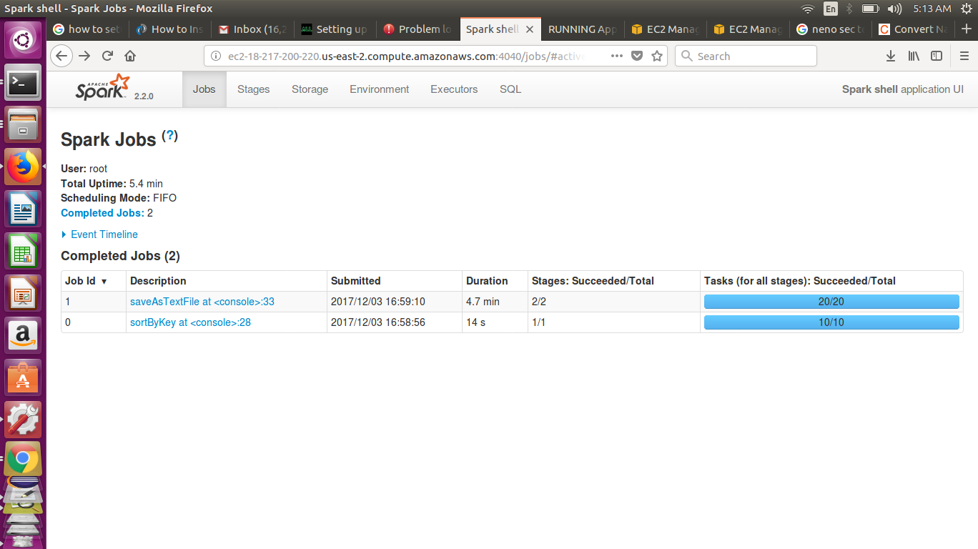

Valsort of output result files:

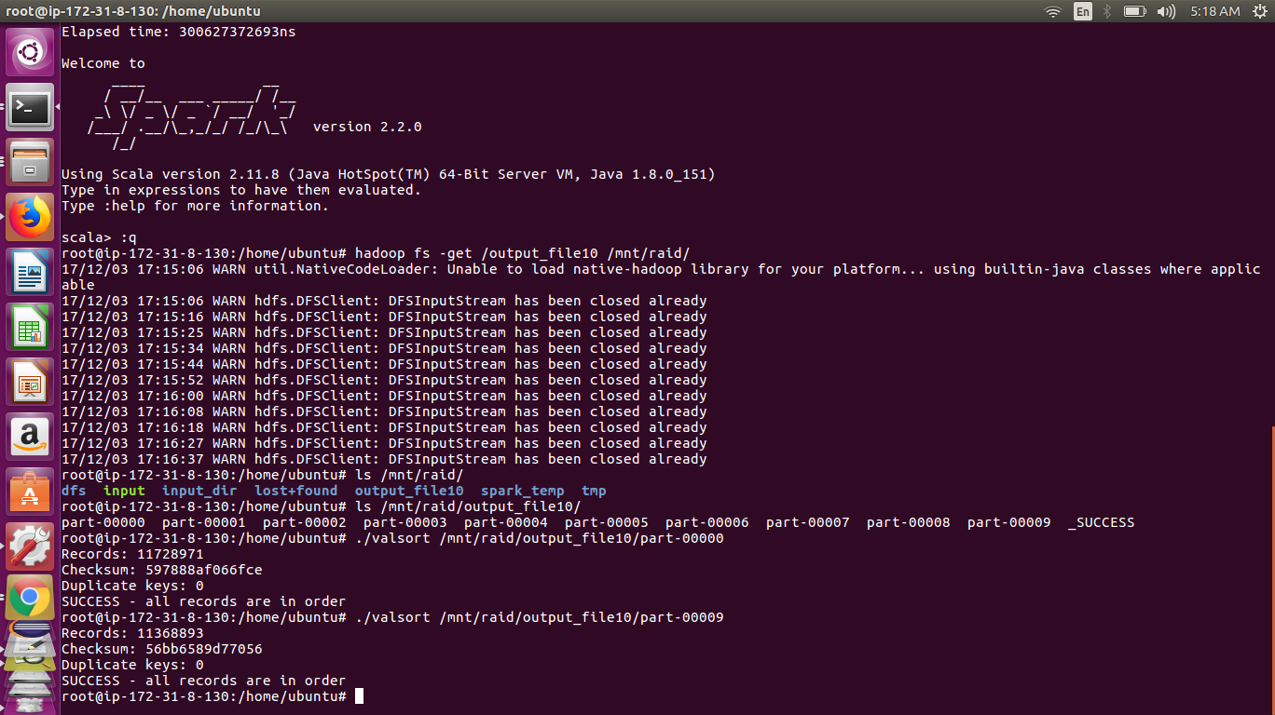

1. **20GB**

Final Result of spark script run

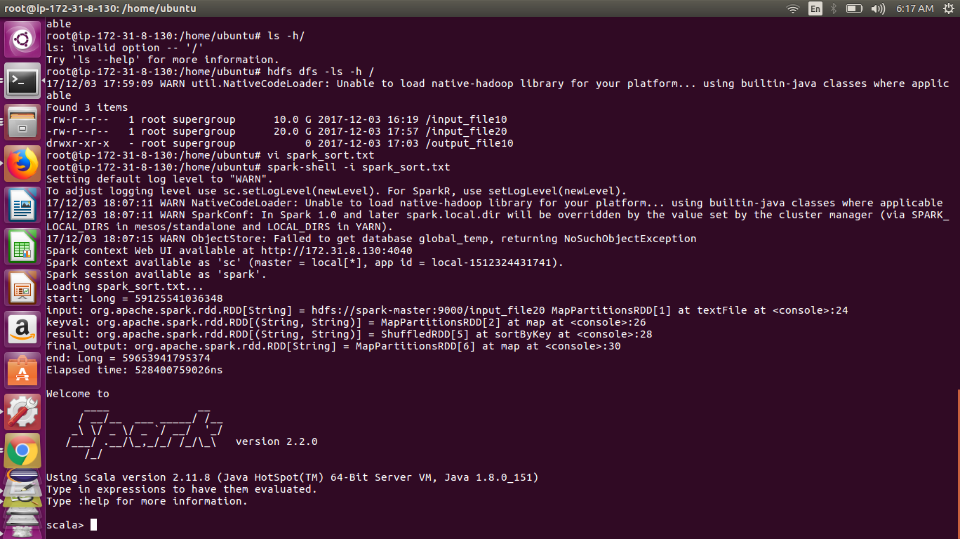

Running Spark Stages in browser

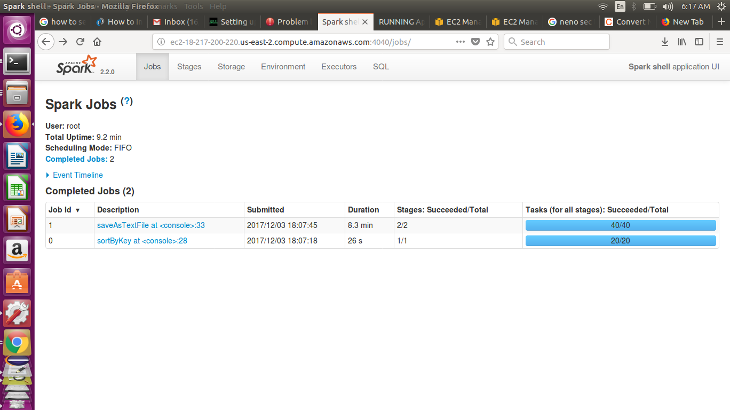

1. **50GB**

Final Result of spark script run

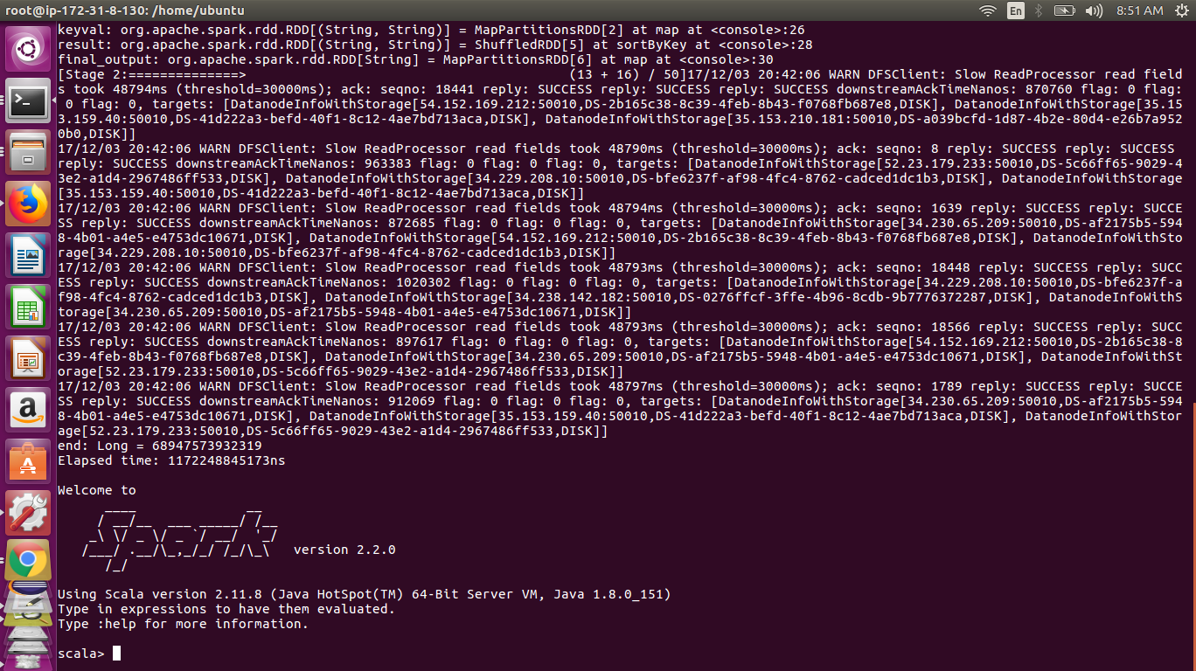

Running Spark Stages in browser

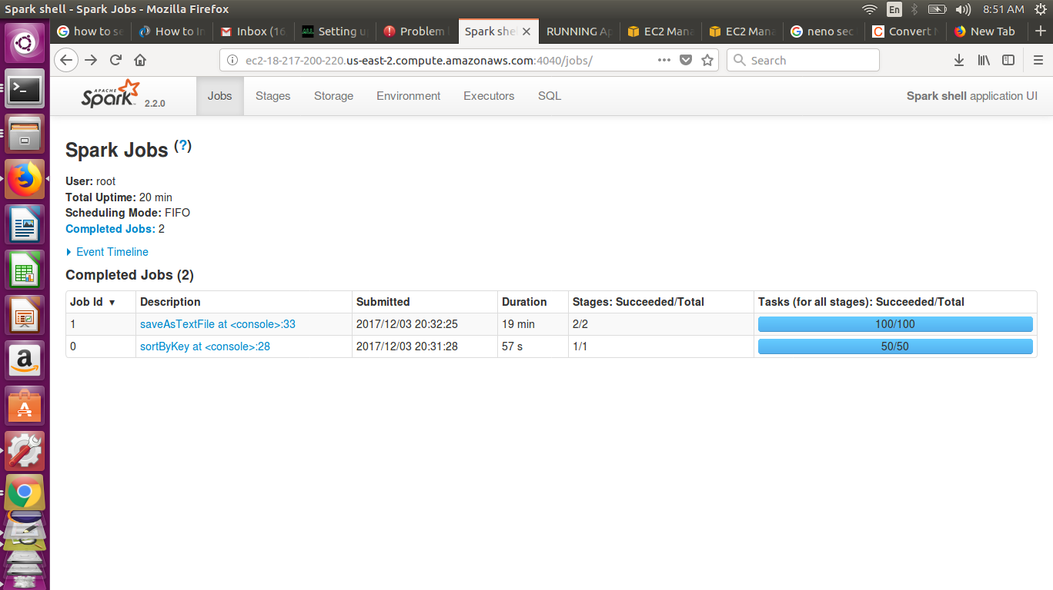

Valsort of output result files:

